PART 1: COMPLETE SETUP (AMAZON LINUX) (PREREQUISITES)
Step 1: Launch EC2 Instance
- OS: Amazon Linux 2 / Amazon Linux 2023
- Instance: t2.medium
- Open Ports:
  - 22 (SSH)
  - 8080 (Jenkins)
  - 9000 (SonarQube)
  - 8081 (Nexus)
  - 8082 (Tomcat)
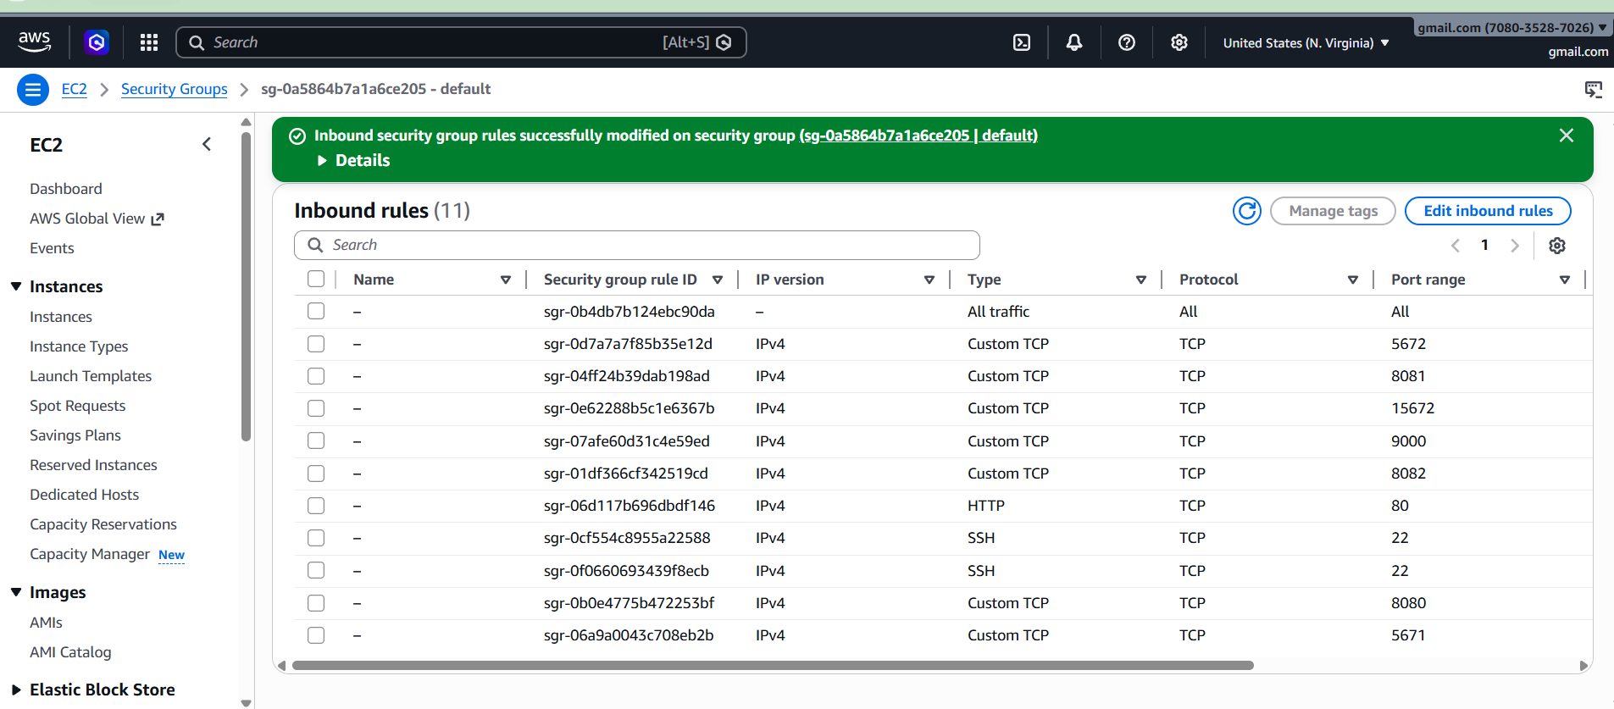
Step 2: Install Java
Amazon Linux 2:
sudo yum install java-17-openjdk -y
Amazon Linux 2023:
sudo dnf install java-17-amazon-corretto -y
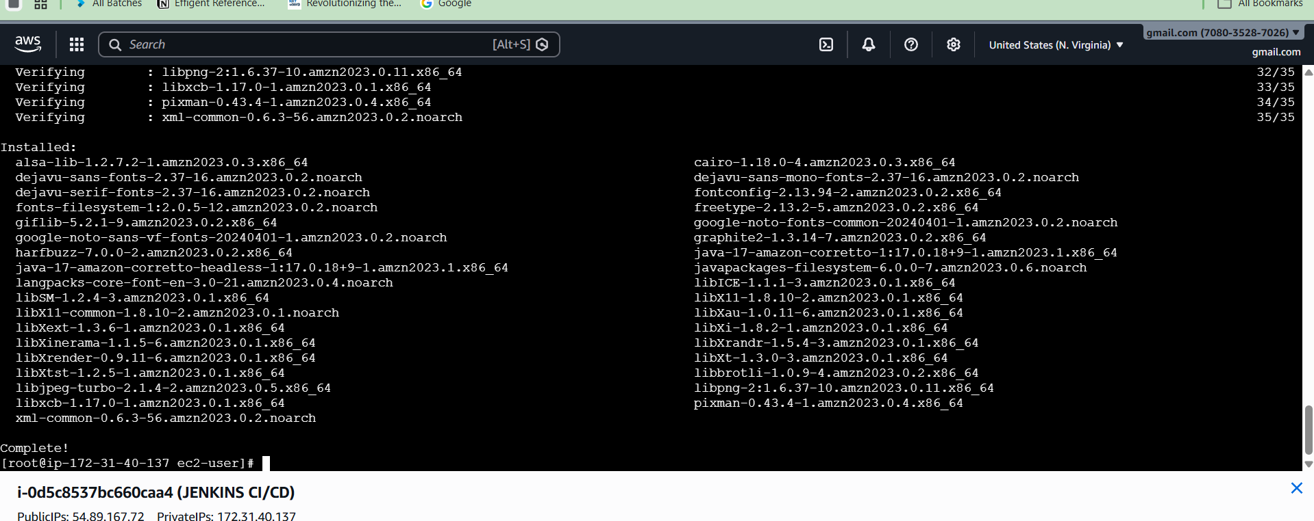
Verify:
java -version

Step 3: Install Jenkins
sudo wget -O /etc/yum.repos.d/jenkins.repo \
https://pkg.jenkins.io/redhat-stable/jenkins.repo
sudo rpm --import https://pkg.jenkins.io/redhat-stable/jenkins.io.key
sudo yum install jenkins -y
sudo systemctl start jenkins
sudo systemctl enable Jenkins
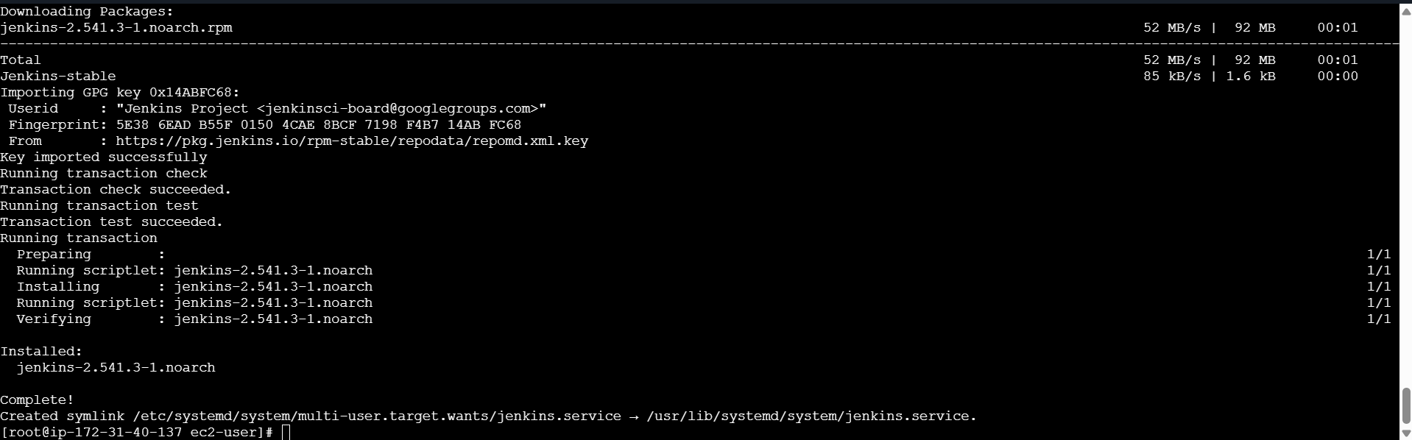
Access:
http://<EC2-IP>:8080
Get password:
sudo cat /var/lib/jenkins/secrets/initialAdminPassword

Step 4: Install Docker
sudo yum install docker -y
sudo systemctl start docker
sudo systemctl enable docker
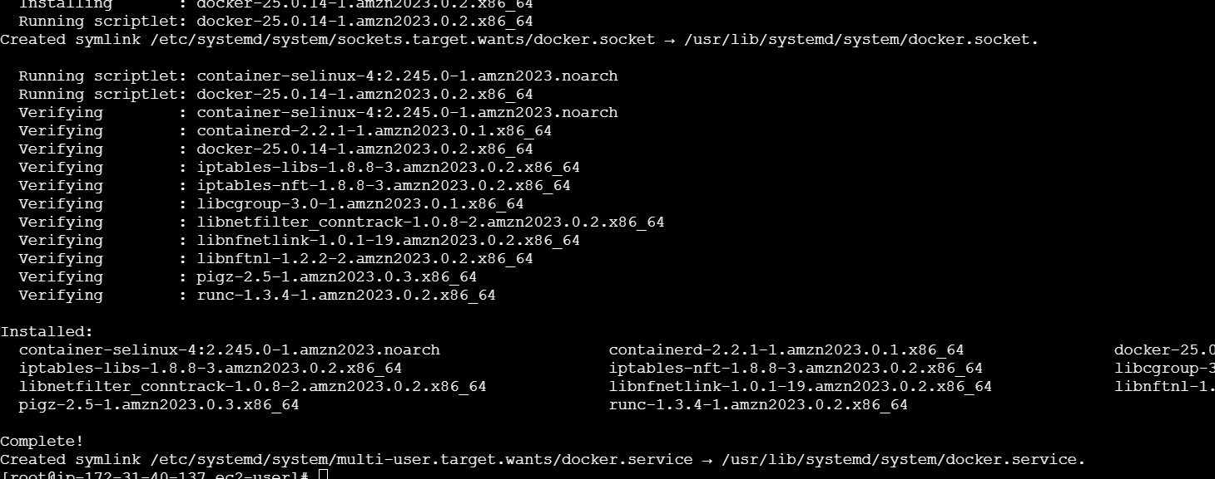
Add permissions:
sudo usermod -aG docker ec2-user
sudo usermod -aG docker jenkins
Restart:
sudo reboot
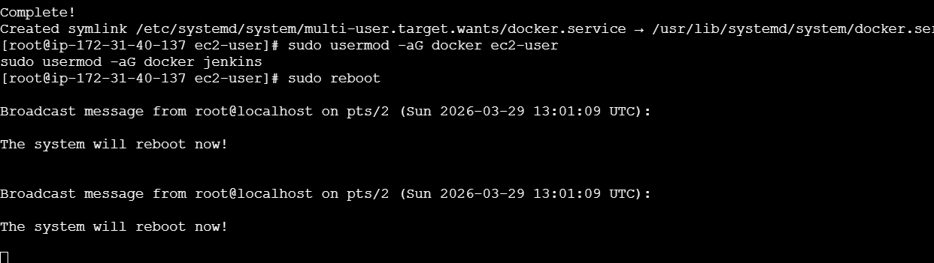

Step 5: Install Maven
sudo yum install maven -y
Verify:
mvn -version
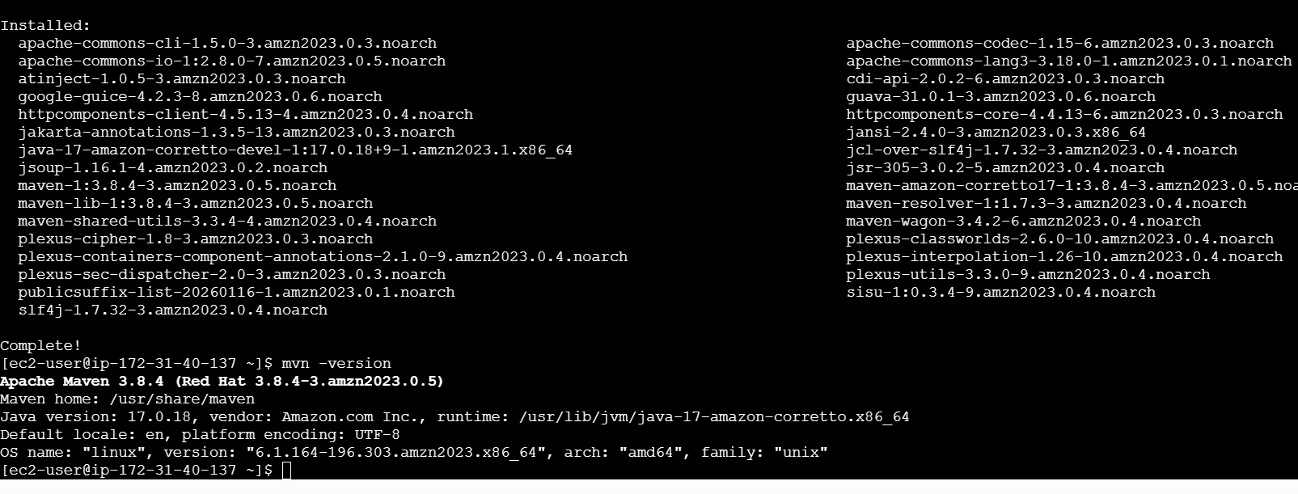

Step 6: Install SonarQube (Docker)
docker run -d --name sonar \
-p 9000:9000 sonarqube:lts
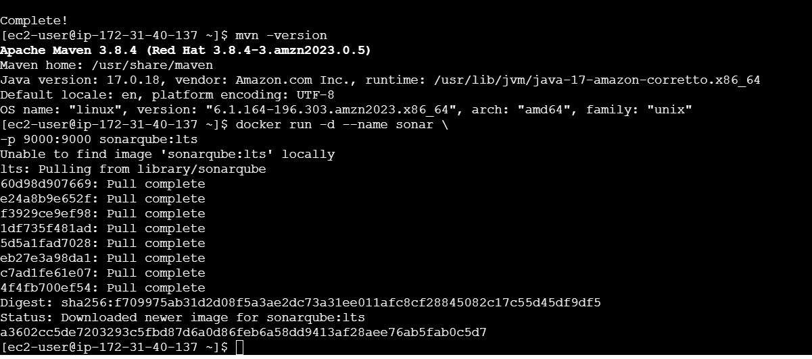
URL:
http://<EC2-IP>:9000
Login:
admin / admin
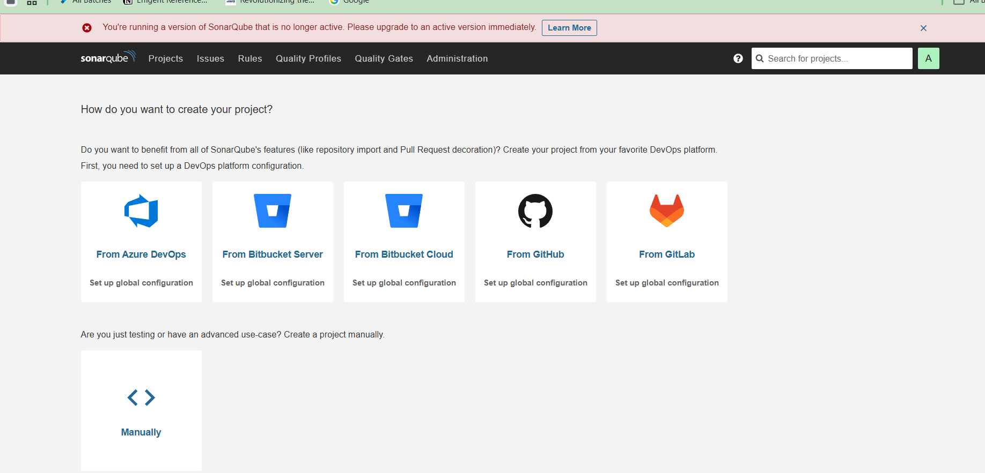
➡️ Generate Token
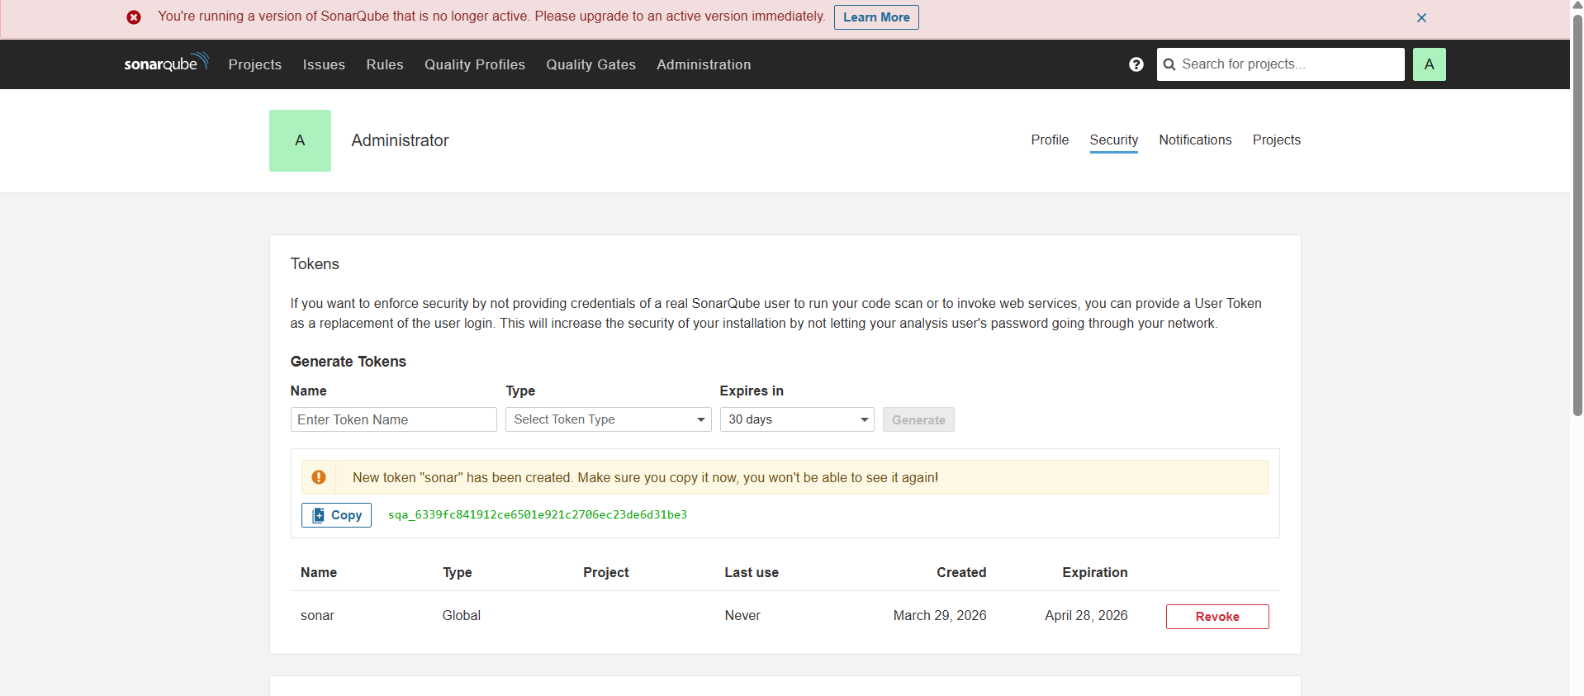

Step 7: Install Nexus (Docker)
docker run -d --name nexus \
-p 8081:8081 sonatype/nexus3
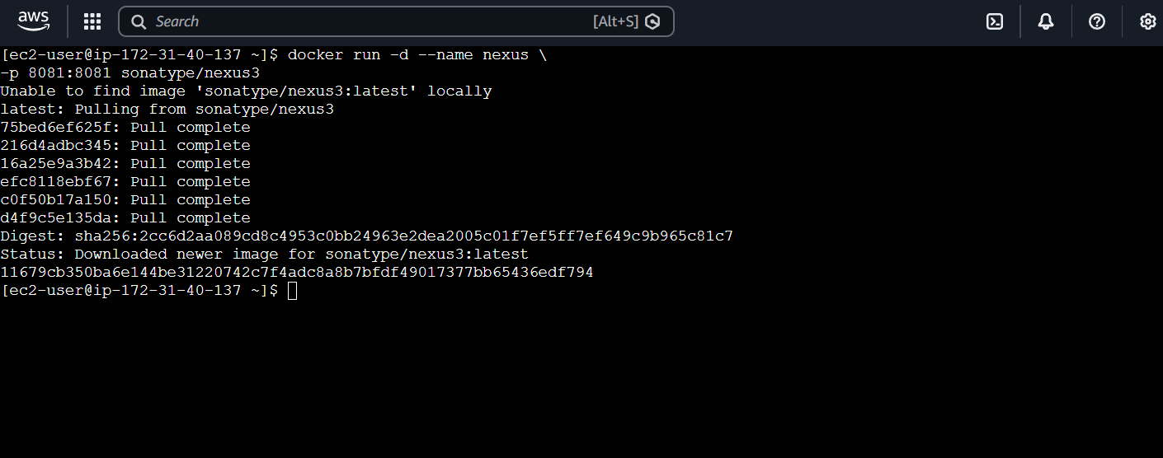
URL:
http://<EC2-IP>:8081
Password:
docker exec -it nexus cat /nexus-data/admin.password
• Username: admin
• Password: 21a80926-d12d-4ce6-8d00-48db7f45690d
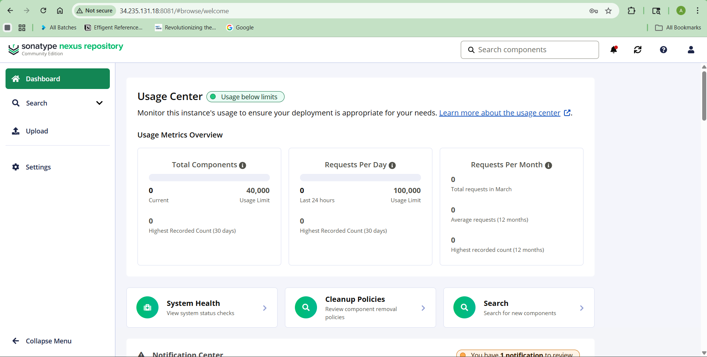

Step 8: Install Tomcat (Docker)
docker run -d --name tomcat \
-p 8082:8080 tomcat

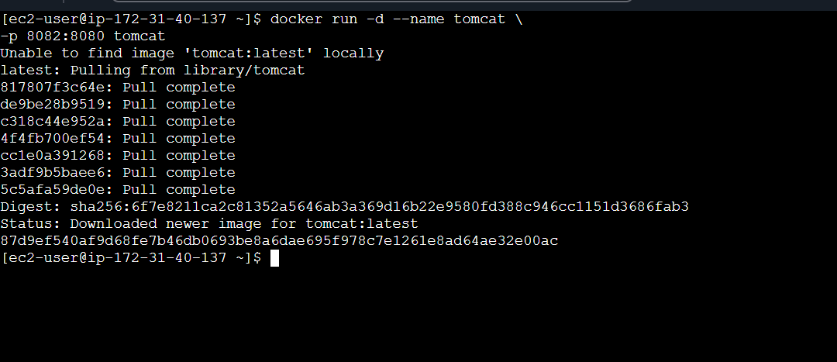
URL:
http://<EC2-IP>:8082

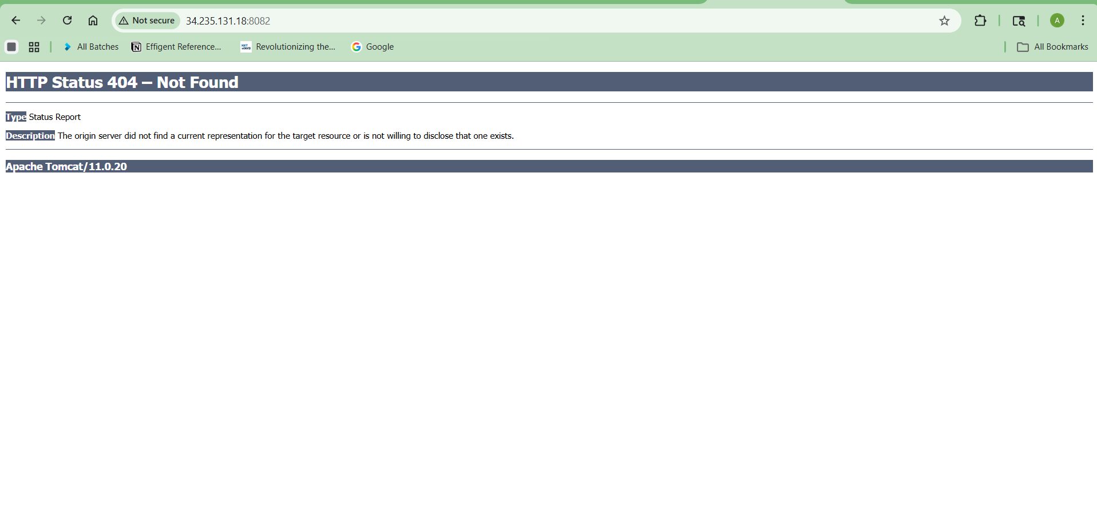

Step 9: Configure Jenkins Plugins
Install:
- Git
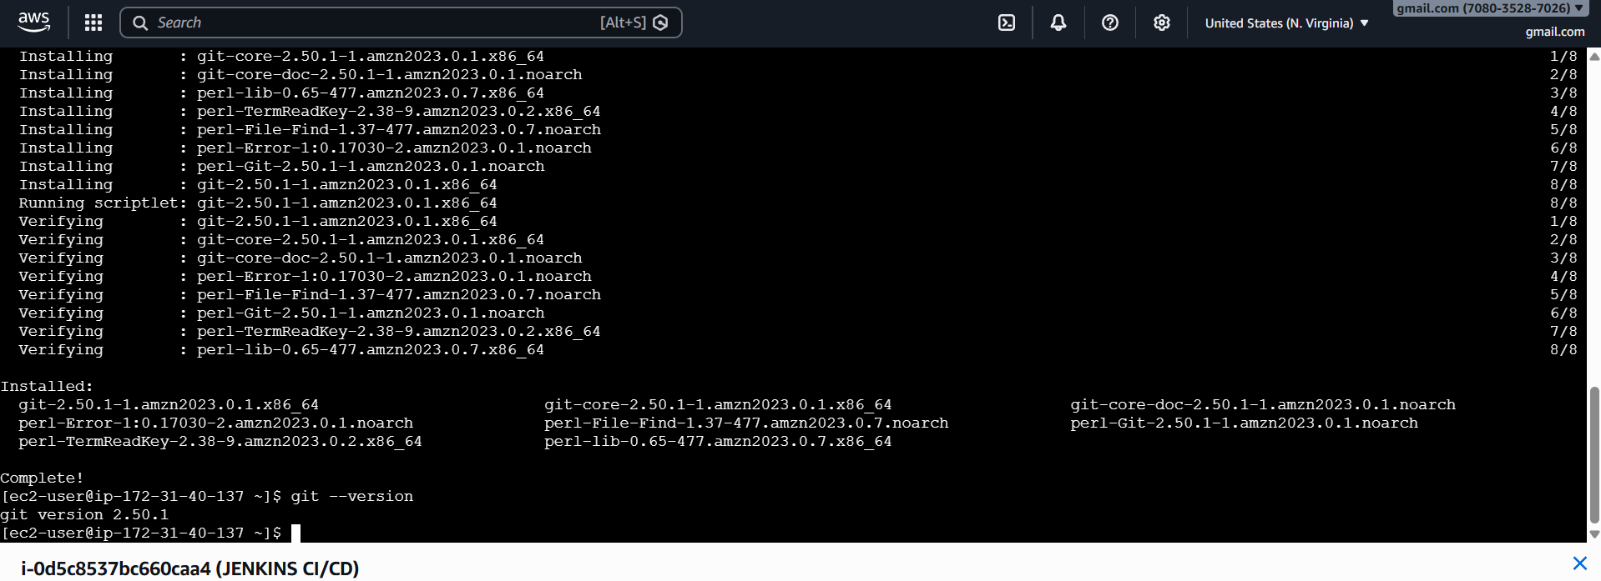
- Maven Integration
- SonarQube Scanner
- Nexus Artifact Uploader
- Slack Notification
- Pipeline
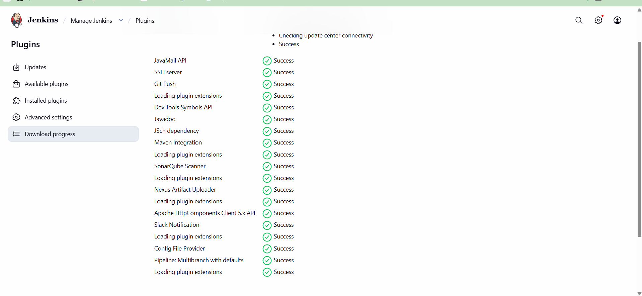

GLOBAL TOOL CONFIG (AMAZON LINUX)
Manage Jenkins → Global Tool Configuration
Now plugins are installed, but tools must be configured.
Go to:
Manage Jenkins → Global Tool Configuration

🔹 Configure Git
- Name: Git
- Path: /usr/bin/git

🔹 Configure Maven
- Click Add Maven
- Name: Maven
- Tick: Install automatically

🔹 Configure SonarQube Scanner
- Click Add SonarQube Scanner
- Name: SonarScanner
- Tick: Install automatically

Step 9.1: Configure SonarQube Server
Go to:
Manage Jenkins → Configure System
Find:
SonarQube Servers
Add:
- Name: SonarQube
- Server URL: http://<SonarQube-IP>:9000
- Add Token (from SonarQube)
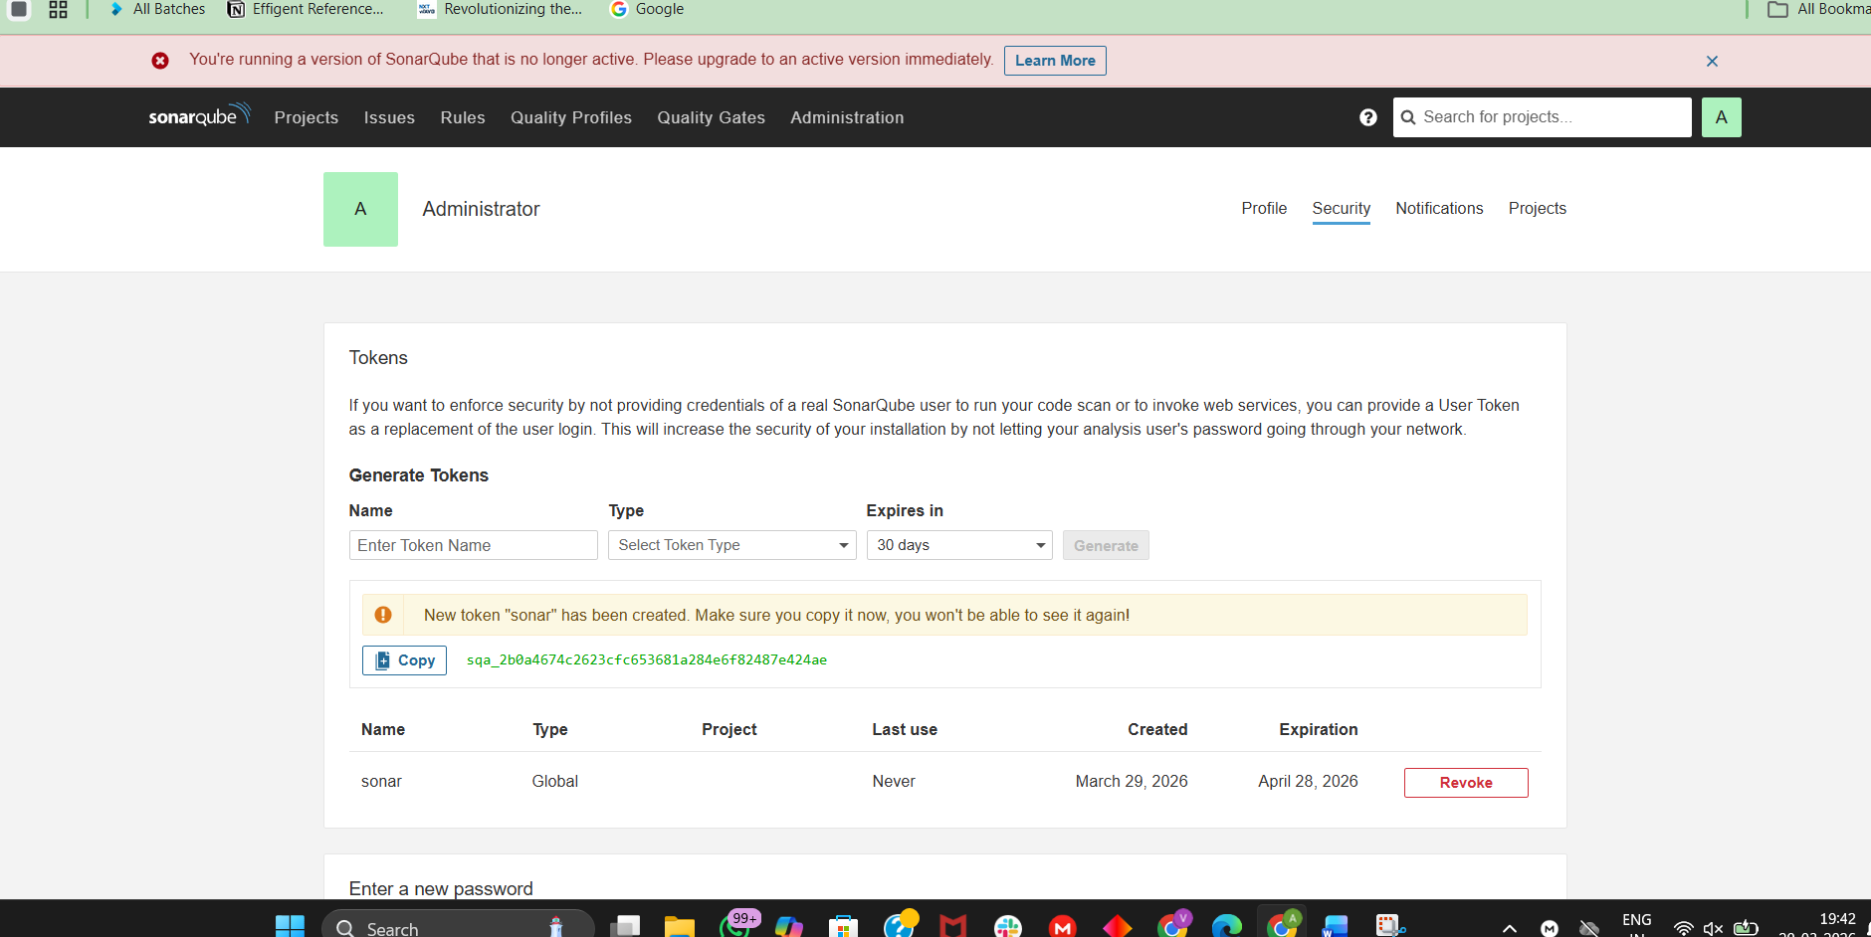

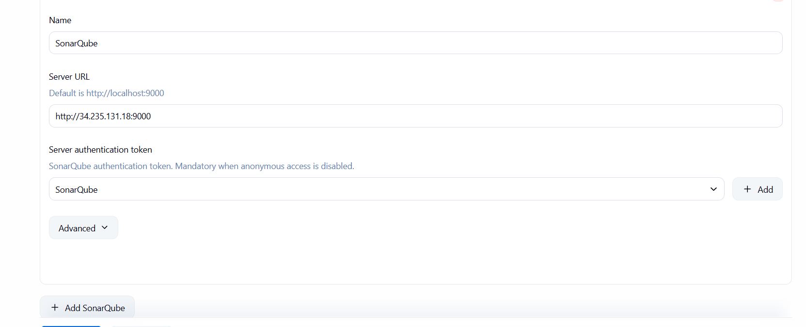

Step 9.2: Configure Slack
Go to:
Manage Jenkins → Configure System
Find:
Slack
Add:
- Workspace
- Channel: #jenkins
- Token Credential (Slack Webhook or Bot Token)
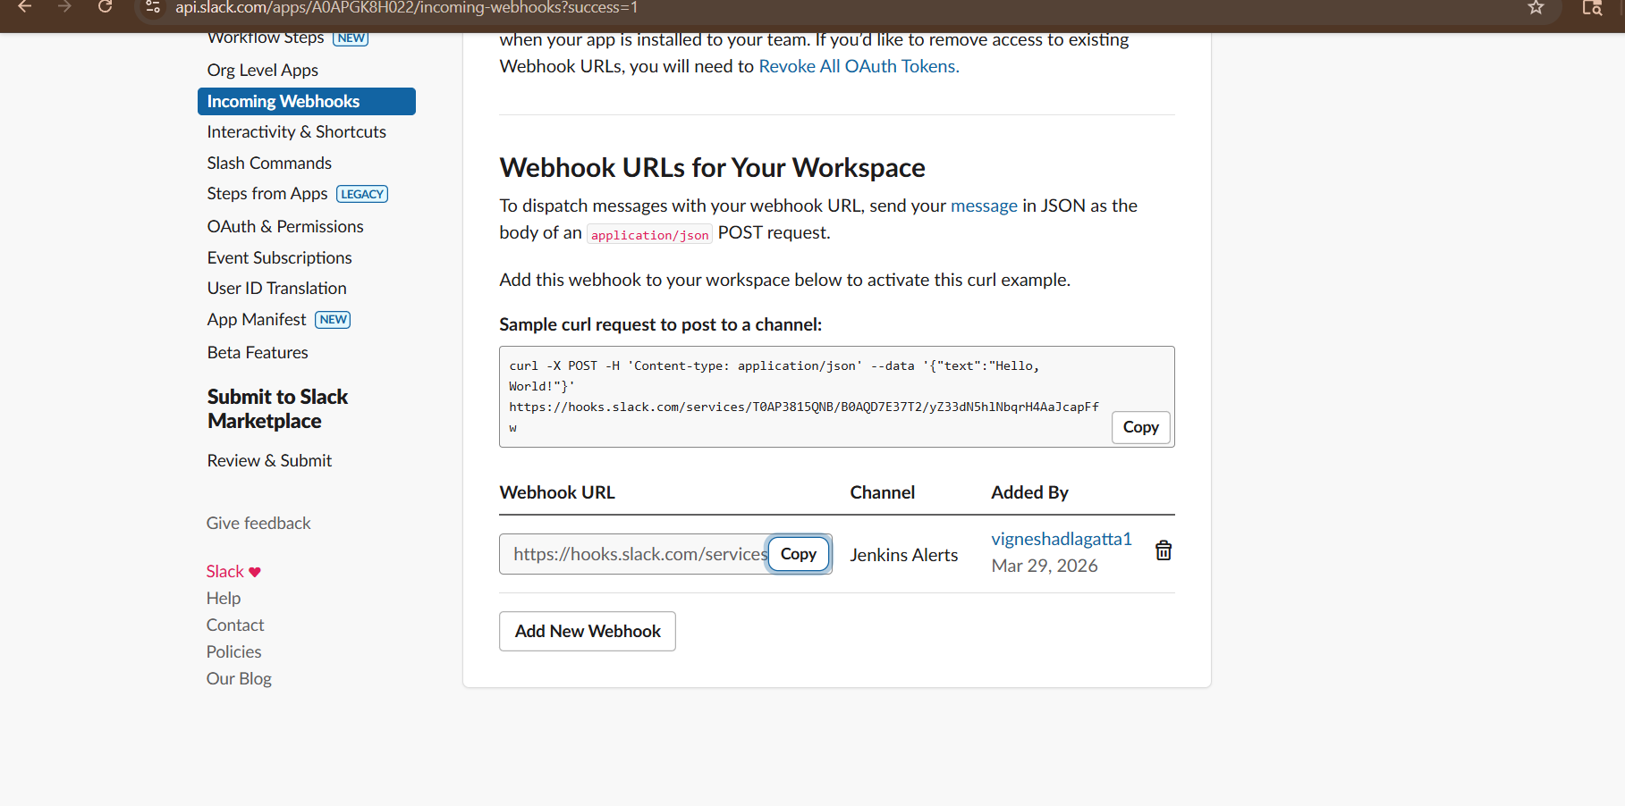
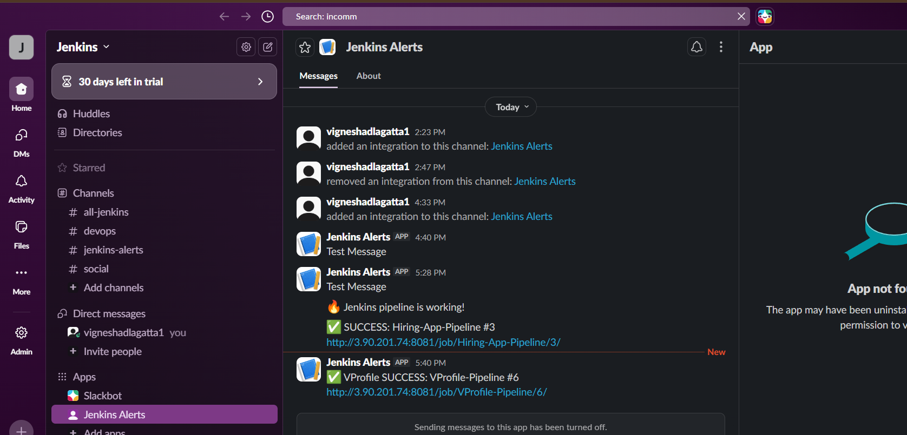
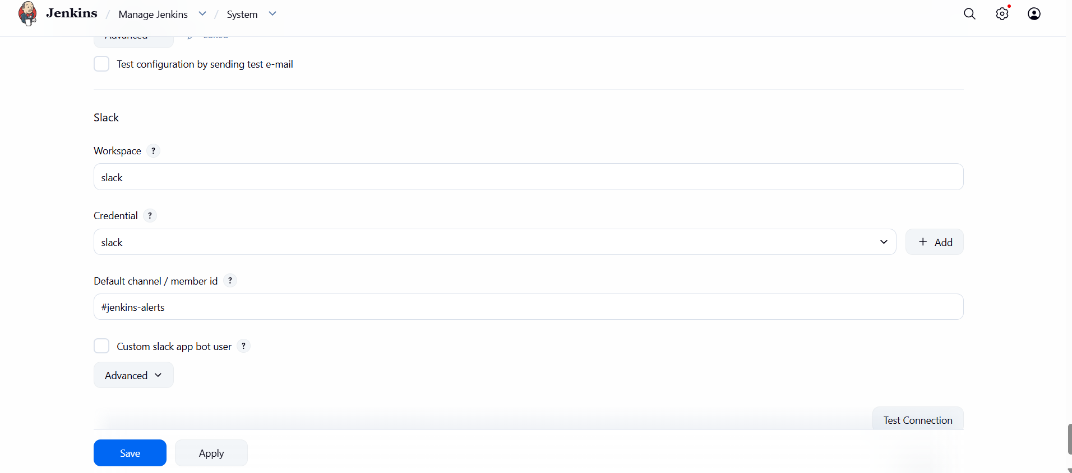

STEP 10: GLOBAL TOOL CONFIG (AMAZON LINUX)
Manage Jenkins → Global Tool Configuration
Configure JDK
Path (check using readlink -f $(which java)):
/usr/lib/jvm/java-17-openjdk
- Name: JDK17
- Uncheck auto install
- Add path

Configure Maven
/usr/share/maven
- Name: Maven

Configure Sonar Scanner
- Name: SonarScanner
- Install automatically ✔

STEP 11: SONARQUBE INTEGRATION
Manage Jenkins → Configure System

Add SonarQube Server
- Name: SonarQube
- URL:
http://<EC2-IP>:9000

Add Token
SonarQube:
My Account → Security → Tokens
Jenkins:
Manage Jenkins → Credentials
- Kind: Secret Text
- ID: sonar-token

Connect Token
Select sonar-token in Sonar config
✔ Enable environment variables

PART 2: FREESTYLE JOB
Step 1: Create Job
Freestyle Project

Step 2: Git Clone
https://github.com/betawins/hiring-app.git

Step 3: Build
Maven Build
Click:
✔ Invoke top-level Maven targets
Fill:
- Maven Version: Maven (from Step 10)
- Goals:
clean package
This does:
✔ Compile code
✔ Create .war file
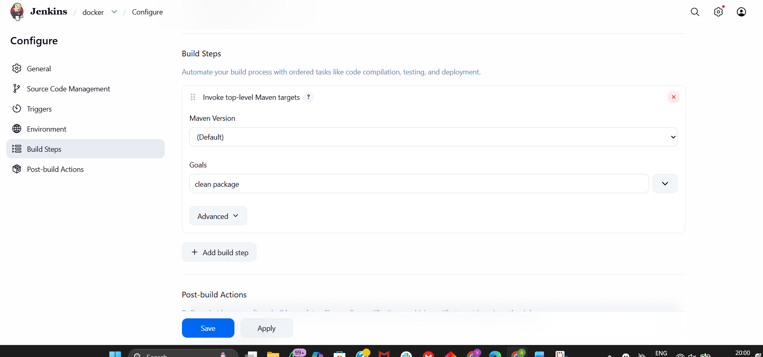

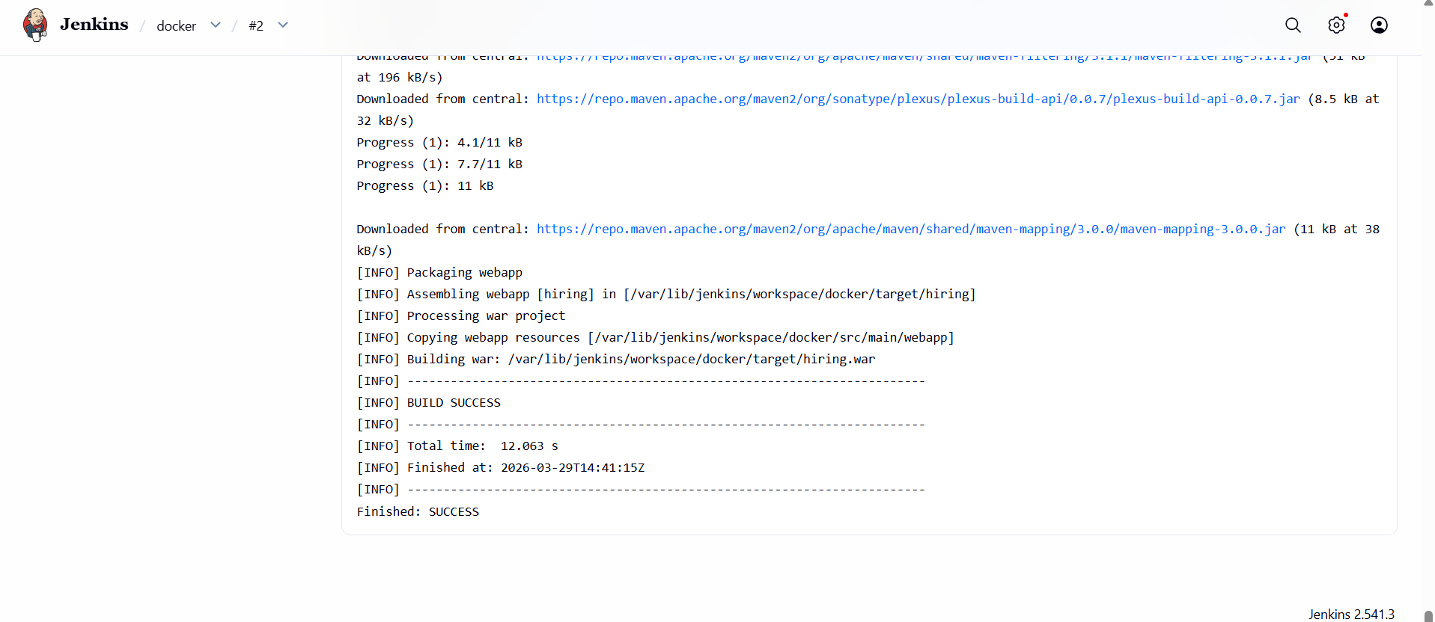
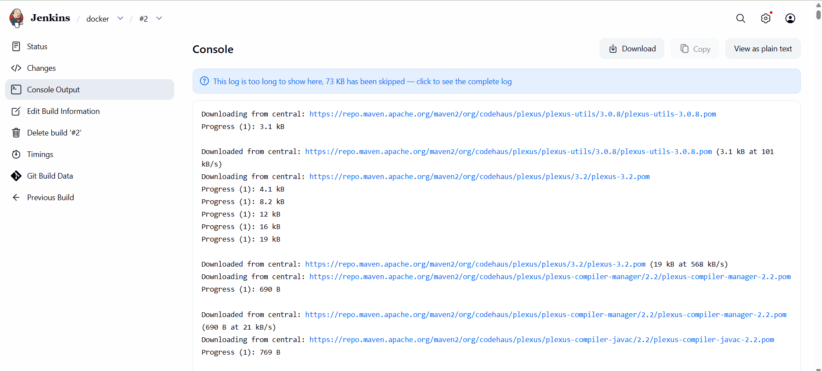

Step 4: SonarQube Analysis
Add Execute Shell:
mvn sonar:sonar \
-Dsonar.projectKey=hiring-app \
-Dsonar.host.url=http://<EC2-IP>:9000 \
-Dsonar.login=<TOKEN>
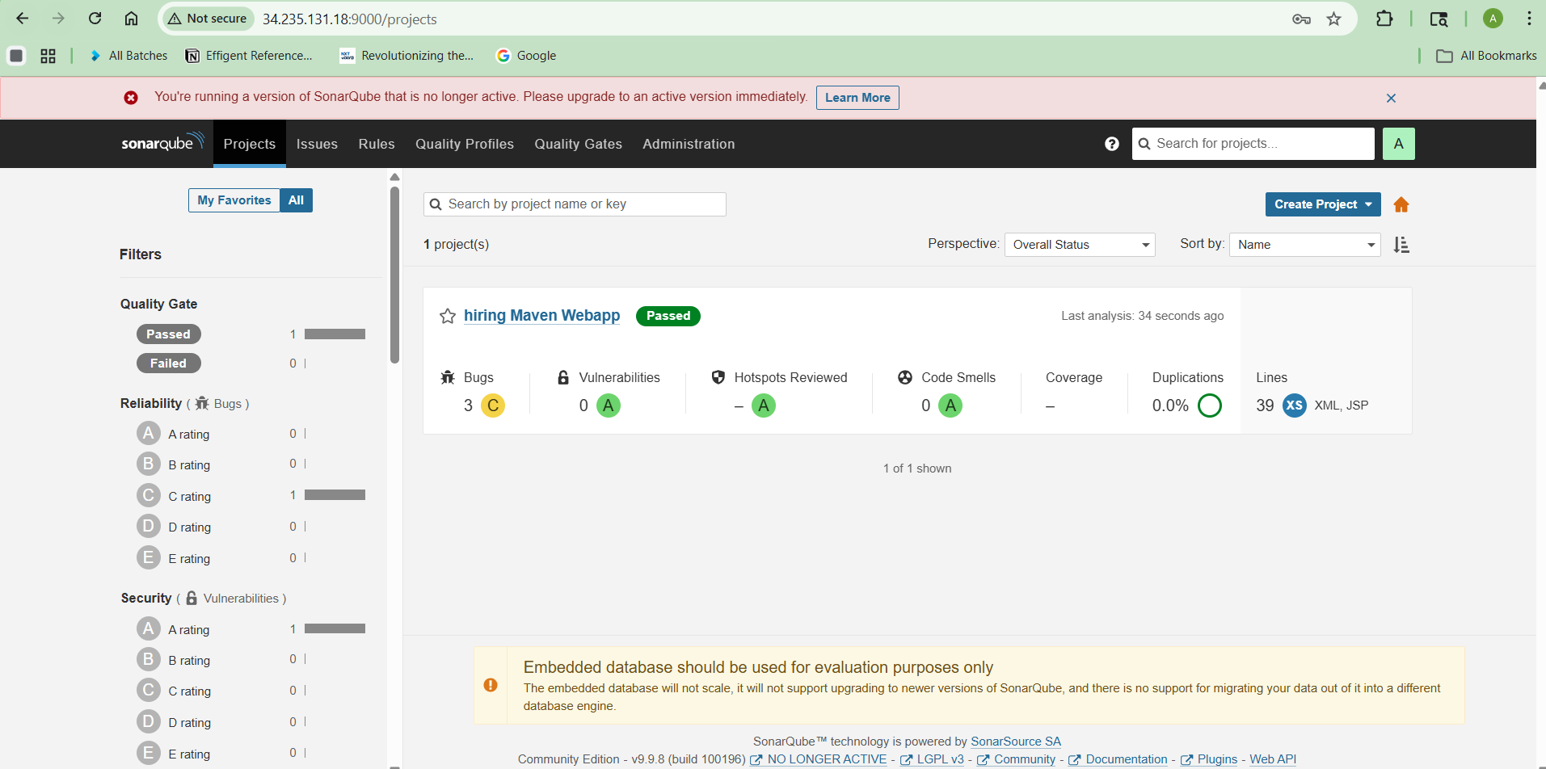

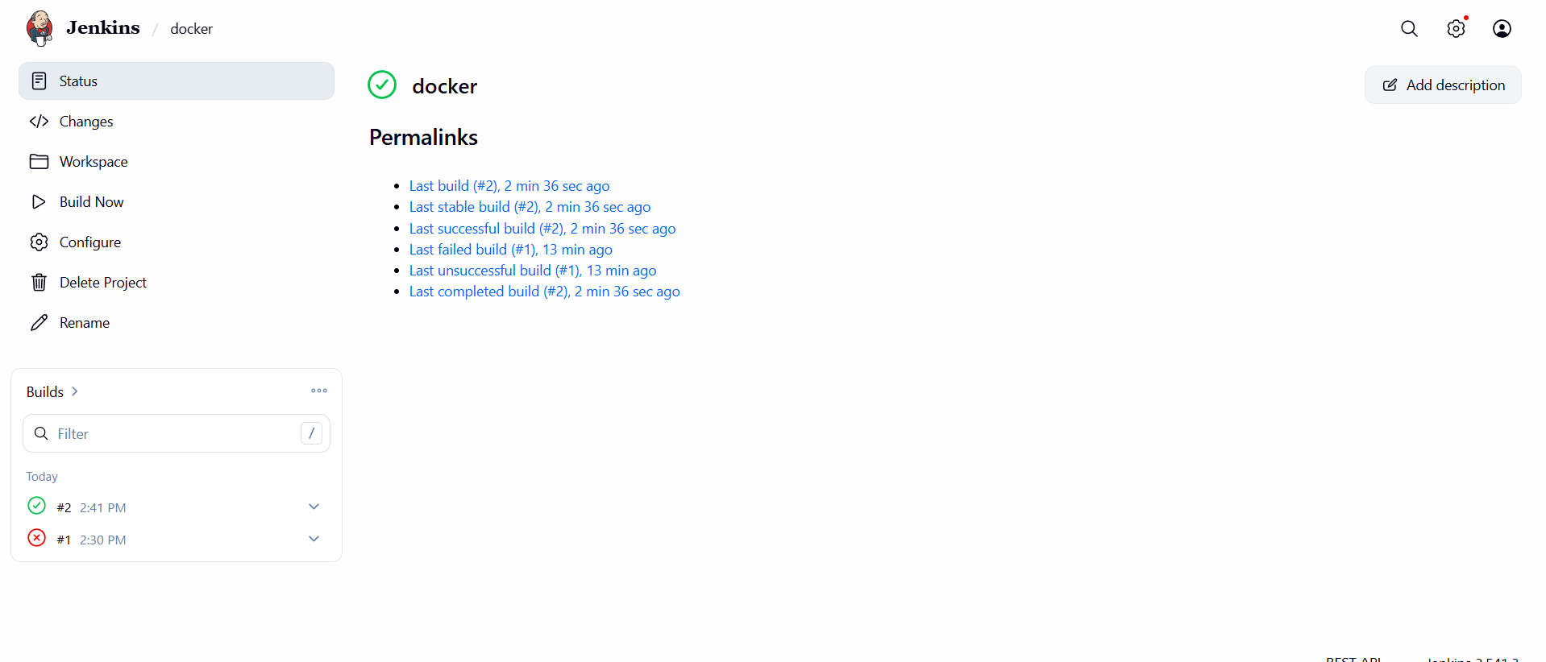
Step 5: Upload to Nexus
Add post-build:
- Artifact: target/*.war
- Repository: releases
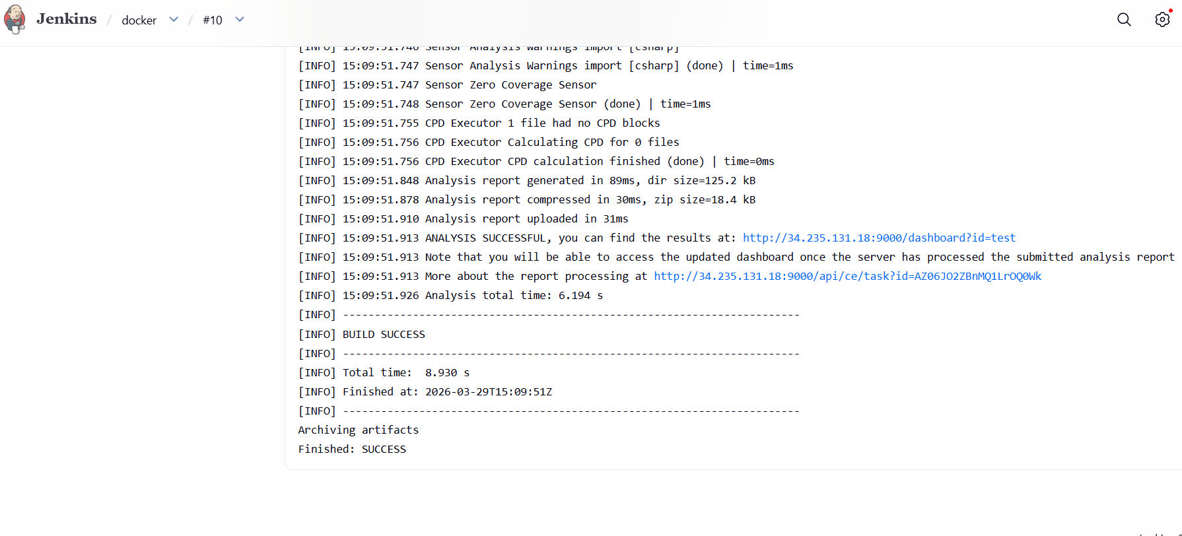

Step 6: Deploy to Tomcat
cp target/*.war /opt/tomcat/webapps/
(If Docker Tomcat → use docker cp)
docker cp target/*.war tomcat:/usr/local/tomcat/webapps/
STEP 1: VERIFY PROJECT LOCATION
Run:
pwd
You are currently:
/home/ec2-user
But your project is NOT here

STEP 2: GO TO JENKINS WORKSPACE
Jenkins stores code here:
cd /var/lib/jenkins/workspace/
ls
You’ll see your job name:
docker (or your job name)
Go inside:
cd docker
ls

STEP 3: CHECK TARGET FOLDER
ls target
You should see:
something.war
If NOT → build issue

STEP 4: COPY WAR FILE (CORRECT WAY)
Now run:
docker cp target/*.war tomcat:/usr/local/tomcat/webapps/
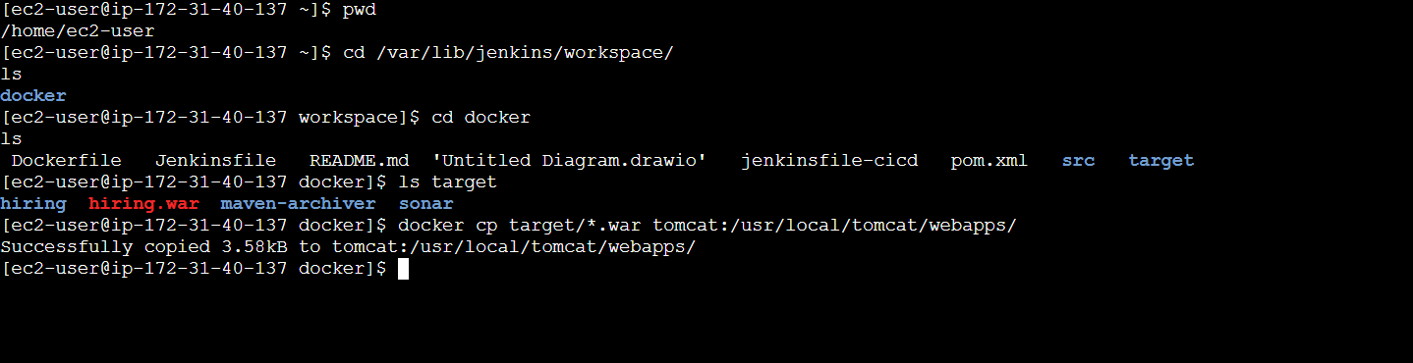
NOW FINAL STEP (VERY IMPORTANT)
Open your application
Go to browser:
http://<EC2-IP>:8082

Then try:
http://<EC2-IP>:8082/hiring
Because your file is:
hiring.war
Tomcat automatically deploys it as:
/hiring
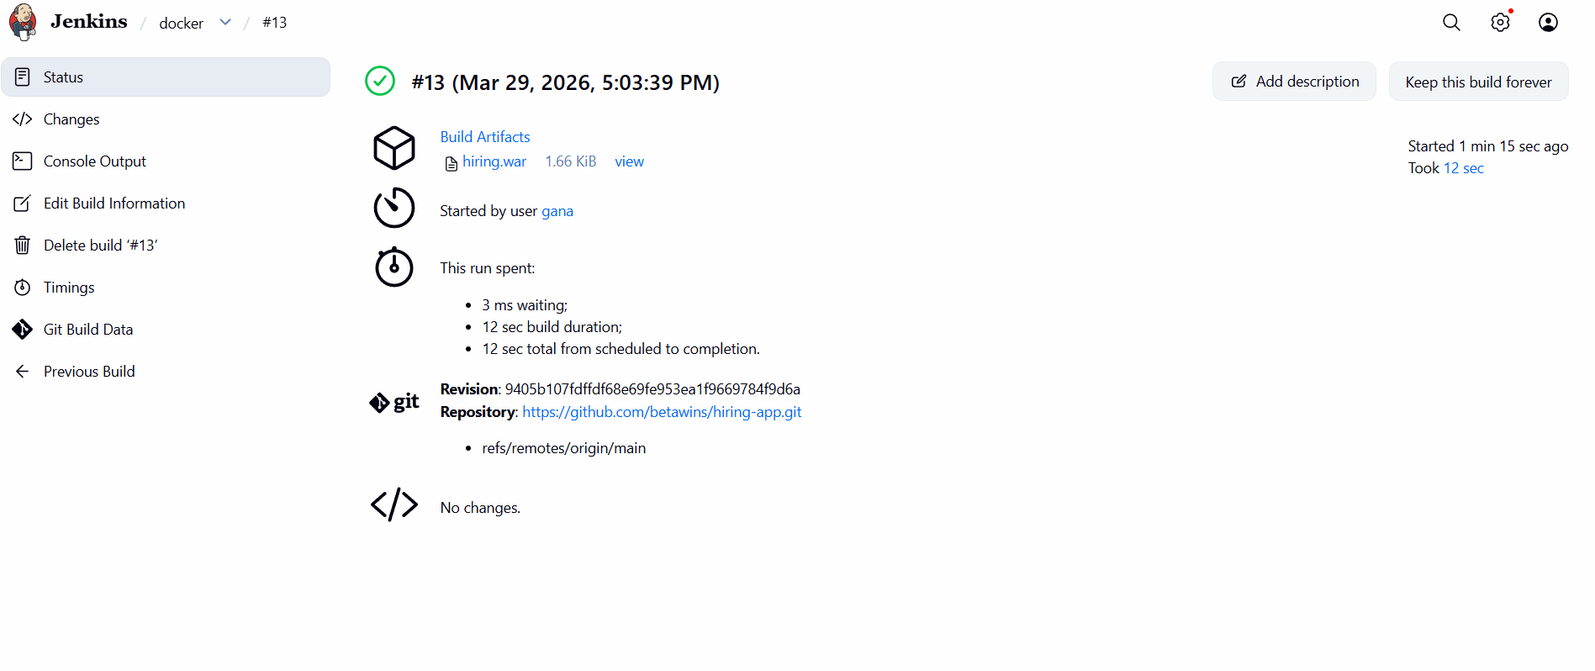

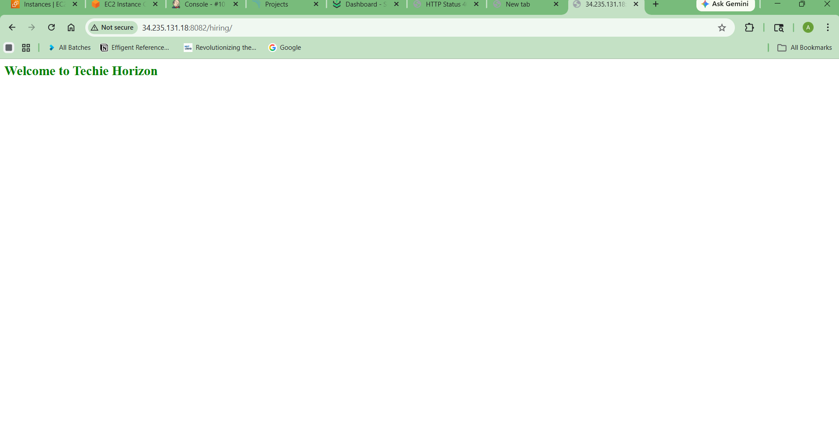

Step 7: Slack Notification
Configure Webhook + Channel
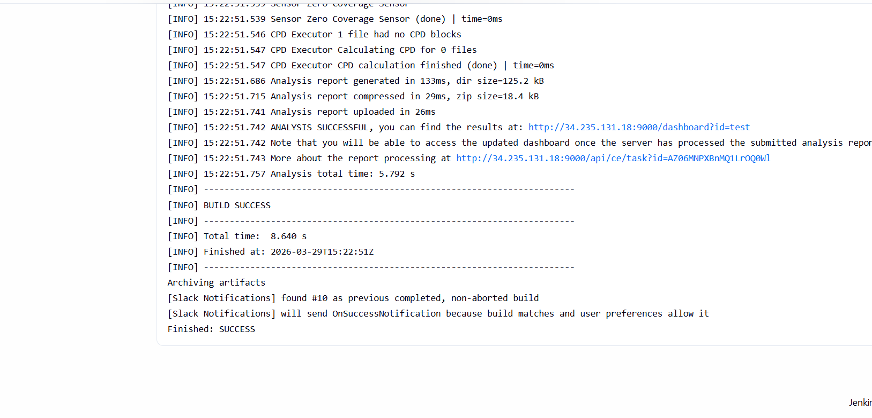

Step 8: Build Job
WHAT JUST ACHIEVED
End-to-End CI/CD working:
✔ Git → Jenkins
✔ Build → Maven
✔ Code Analysis → SonarQube
✔ Artifact → WAR
✔ Deploy → Tomcat

2) Setup a Jenkins CICD pipeline using Declarative pipeline using feature-1.1 branch.
Step 1: Create Pipeline Job
- New Item → Pipeline
- Step 2: Pipeline Script
pipeline {
agent any
tools {
maven 'Maven'
}
environment {
SONAR_URL = "http://34.235.131.18:9000"
NEXUS_URL = "http://34.235.131.18:8081"
}
stages {
stage('Git Clone') {
steps {
git branch: 'feature-1.1',
url: 'https://github.com/betawins/sabear_simplecutomerapp.git'
}
}
stage('Build') {
steps {
sh 'mvn clean package'
}
}
stage('SonarQube Analysis') {
steps {
withCredentials([string(credentialsId: 'sonar-token', variable: 'TOKEN')]) {
sh """
mvn sonar:sonar \
-Dsonar.projectKey=customer-app \
-Dsonar.host.url=$SONAR_URL \
-Dsonar.login=$TOKEN
"""
}
}
}
stage('Deploy to Tomcat') {
steps {
sh 'docker cp target/*.war tomcat:/usr/local/tomcat/webapps/'
}
}
}
post {
success {
echo "Pipeline SUCCESS ✅"
}
failure {
echo "Pipeline FAILED ❌"
}
}
}
REAL-TIME FLOW
👉 Developer pushes code
👉 Jenkins triggers
👉 Code builds via Maven
👉 Sonar checks code quality
👉 WAR uploaded to Nexus
👉 Deployed to Tomcat
👉 Slack notification sent
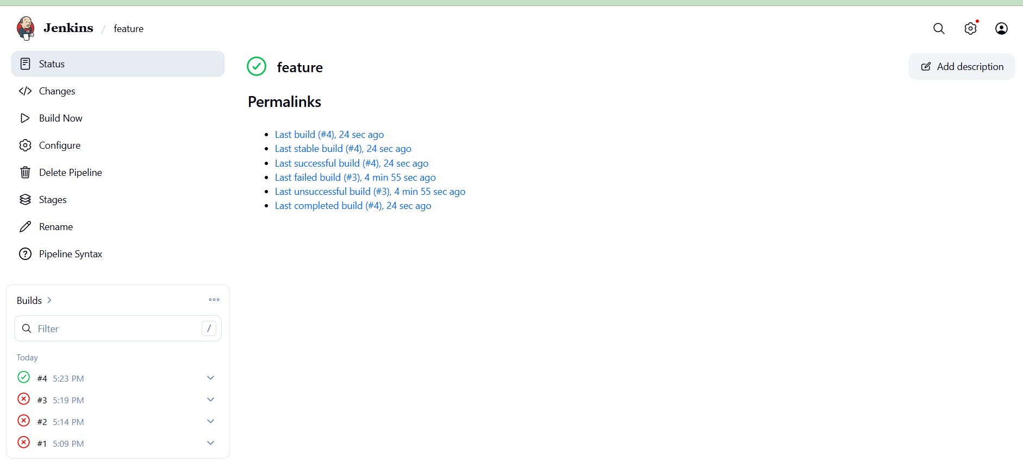
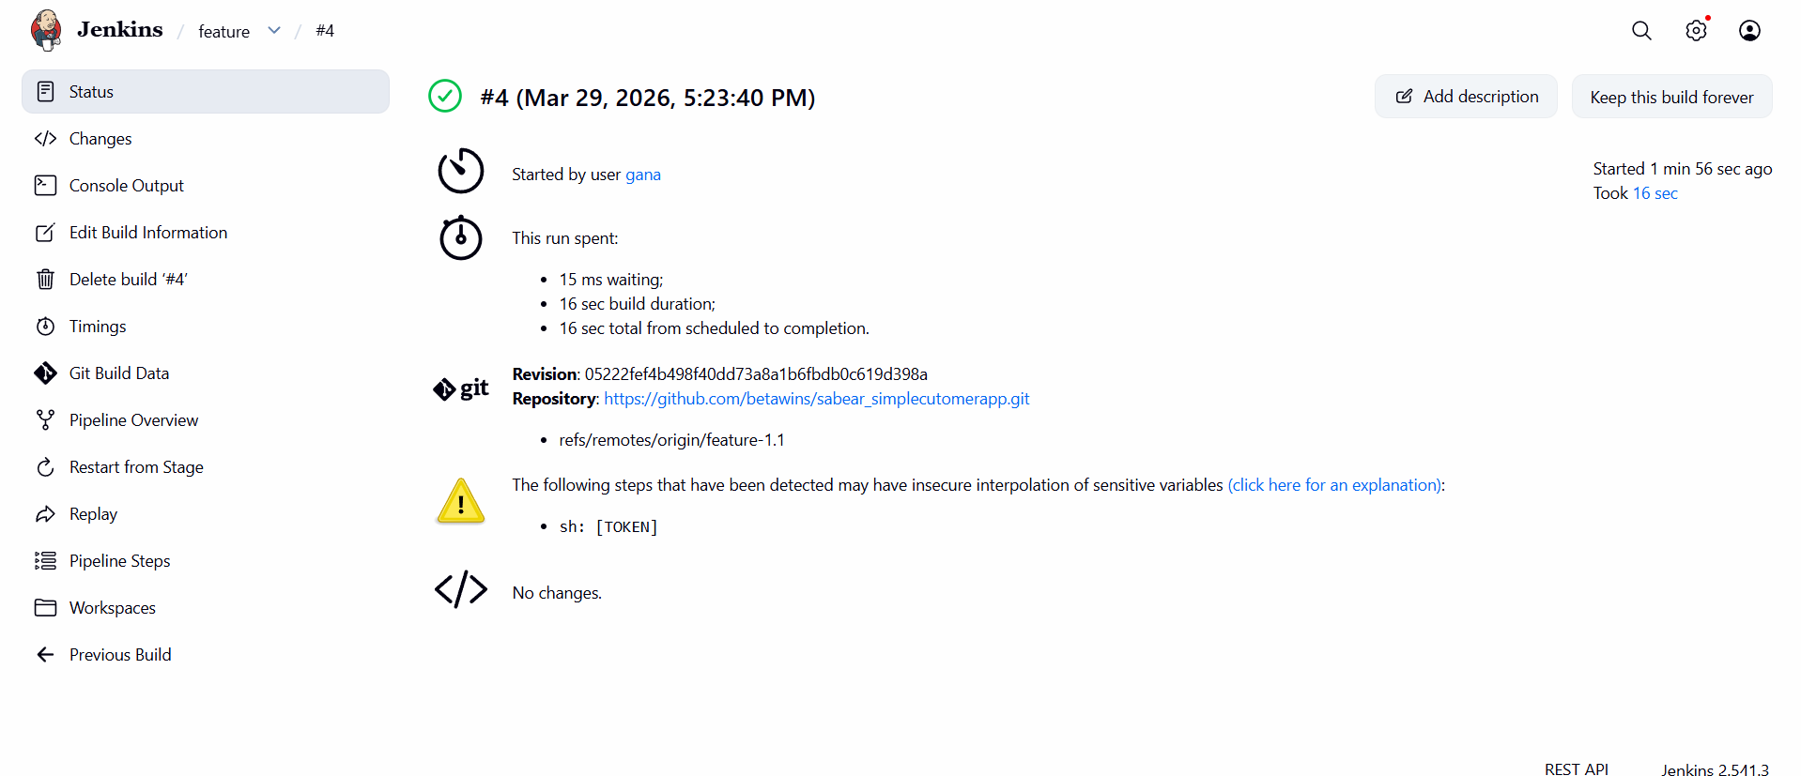
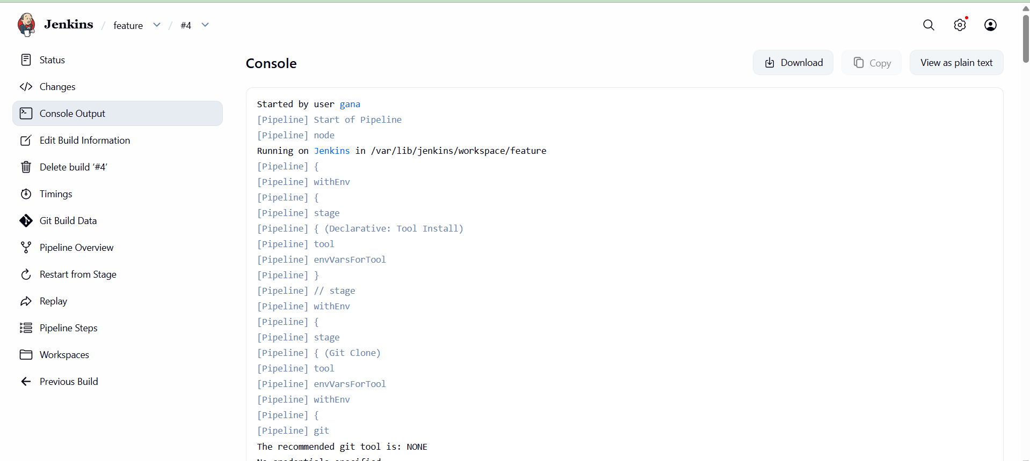

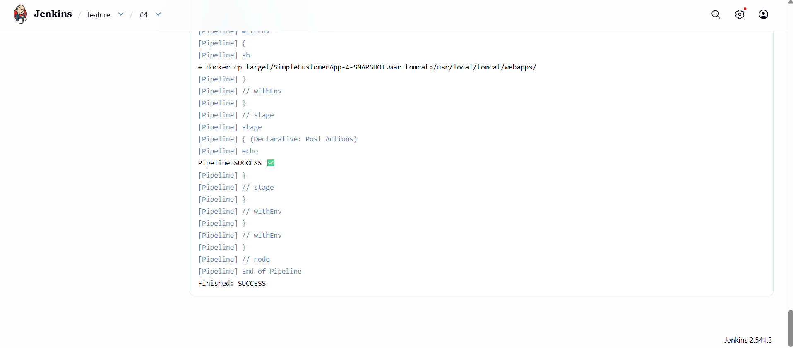

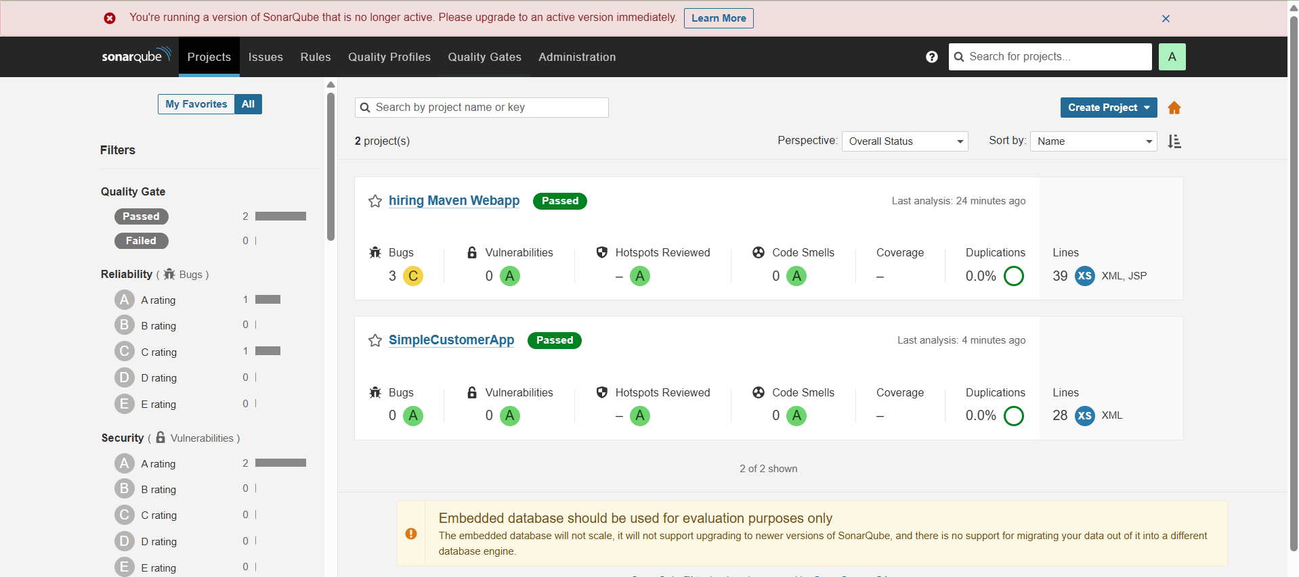

3) Setup a Jenkins CICD pipeline using Scripted pipeline using feature-1.1 branch.

COMPLETE SETUP: Jenkins CI/CD (Scripted Pipeline)
Architecture Flow (Understand First)
Flow will be like this:
GitHub (feature-1.1 branch)
↓
Jenkins Pipeline
↓
SonarQube (Code Quality)
↓
Maven Build (.war)
↓
Nexus (Artifact Store)
↓
Tomcat (Deploy)
↓
Slack Notification

STEP 1: Prerequisites Setup (VERY IMPORTANT)
Install Required Tools (on Jenkins server)
sudo yum update -y
sudo yum install git java-11-openjdk maven -y
Install Jenkins
sudo wget -O /etc/yum.repos.d/jenkins.repo \
https://pkg.jenkins.io/redhat-stable/jenkins.repo
sudo rpm --import https://pkg.jenkins.io/redhat-stable/jenkins.io.key
sudo yum install jenkins -y
sudo systemctl start jenkins
sudo systemctl enable jenkins
Access Jenkins:
http://<EC2-IP>:8080

STEP 2: Configure Jenkins
Install Plugins:
Go to Manage Jenkins → Plugins
Install:
- Git plugin
- Maven Integration
- Pipeline
- SonarQube Scanner
- Nexus Artifact Uploader
- Slack Notification

STEP 3: Configure Global Tools
Manage Jenkins → Global Tool Configuration
Add:
- JDK → jdk11
- Maven → maven3
- Sonar Scanner → sonar-scanner

STEP 4: Setup SonarQube
Run SonarQube (Docker recommended)
docker run -d --name sonar -p 9000:9000 sonarqube:lts
Access:
http://<IP>:9000
Default login:
admin / admin
Generate Token:
My Account → Security → Generate Token

Configure in Jenkins:
Manage Jenkins → Configure System
- Add SonarQube server:
  - Name: sonar-server
  - URL: http://<IP>:9000
  - Token: (paste token)

STEP 5: Setup Nexus Repository
Run Nexus:
docker run -d -p 8081:8081 --name nexus sonatype/nexus3
Access:
http://<IP>:8081
Create Repository:
- Go to → Repositories
- Create:
  - maven-releases
  - maven-snapshots

STEP 6: Setup Slack Notification
Create Slack Webhook:
- Go to Slack → Apps → Incoming Webhooks
- Copy URL
Configure in Jenkins:
- Manage Jenkins → Configure System → Slack
- Paste Webhook URL

STEP 7: Setup Tomcat Server
sudo yum install tomcat -y
sudo systemctl start tomcat
sudo systemctl enable tomcat
Deploy path:
/var/lib/tomcat/webapps/

STEP 8: Create Jenkins Pipeline Job
New Item → Pipeline → Name: CI-CD-Pipeline

STEP 9: SCRIPTED PIPELINE (MAIN TASK)
Paste this in Jenkins Pipeline Script:
node {
stage('Clean Workspace') {
deleteDir()
}
stage('Git Clone') {
git branch: 'feature-1.1',
url: 'https://github.com/betawins/sabear_simplecutomerapp.git'
}
stage('SonarQube Analysis') {
withSonarQubeEnv('sonar-server') {
sh """
mvn clean verify sonar:sonar \
-Dsonar.projectKey=customerapp \
-Dsonar.projectName=customerapp
"""
}
}

stage('Build Application') {
sh 'mvn clean package'
}
stage('Get WAR File Name') {
script {
def WAR_FILE = sh(
script: "ls target/*.war",
returnStdout: true
).trim()
env.WAR_FILE = WAR_FILE
echo "WAR FILE: ${env.WAR_FILE}"
}
}
stage('Upload to Nexus') {
nexusArtifactUploader(
nexusVersion: 'nexus3',
protocol: 'http',
nexusUrl: '34.235.131.18:8081',
groupId: 'com.example',
version: "${BUILD_NUMBER}",
repository: 'maven-releases',
credentialsId: 'nexus-creds',
artifacts: [
[
artifactId: 'SimpleCustomerApp',
classifier: '',
file: "${env.WAR_FILE}",
type: 'war'
]
]
)
}
stage('Deploy to Tomcat (Docker)') {
sh """
docker exec tomcat rm -rf /usr/local/tomcat/webapps/*.war || true
docker cp ${env.WAR_FILE} tomcat:/usr/local/tomcat/webapps/
"""
}
stage('Slack Notification') {
slackSend(
channel: '#devops',
message: "✅ CI/CD SUCCESS - Build ${BUILD_NUMBER}"
)
}
}

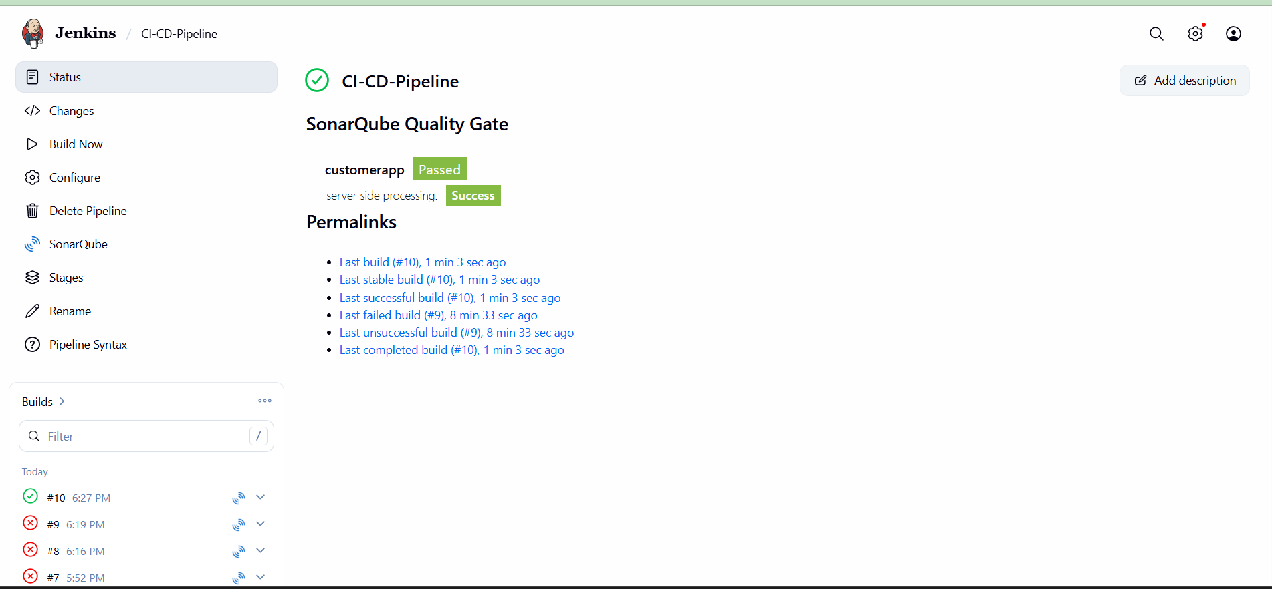
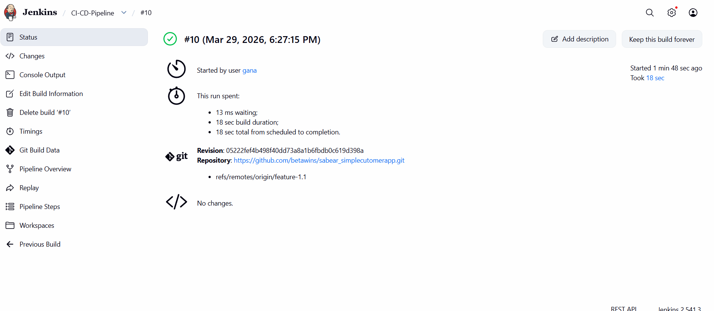

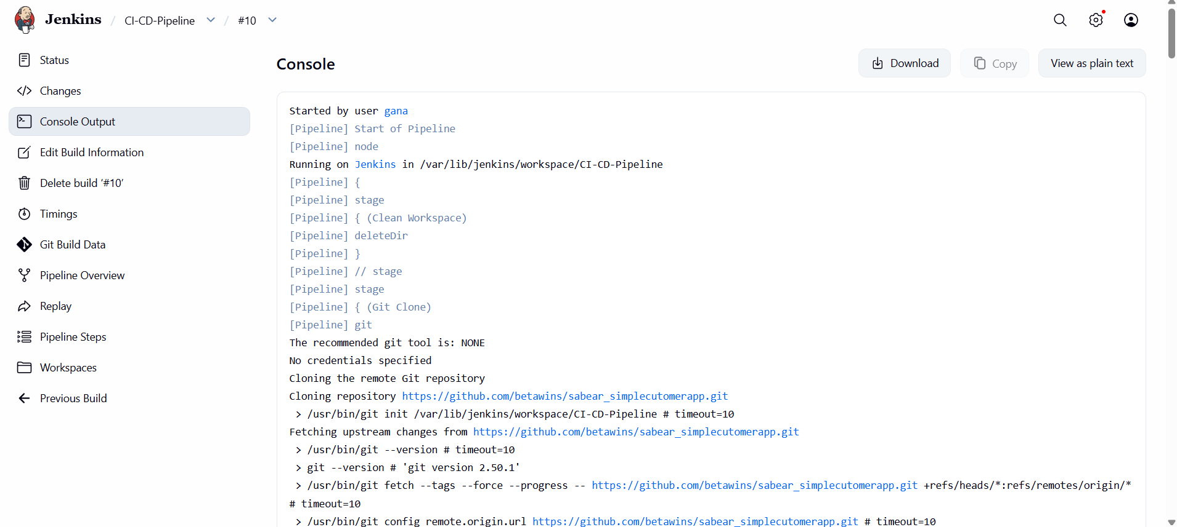

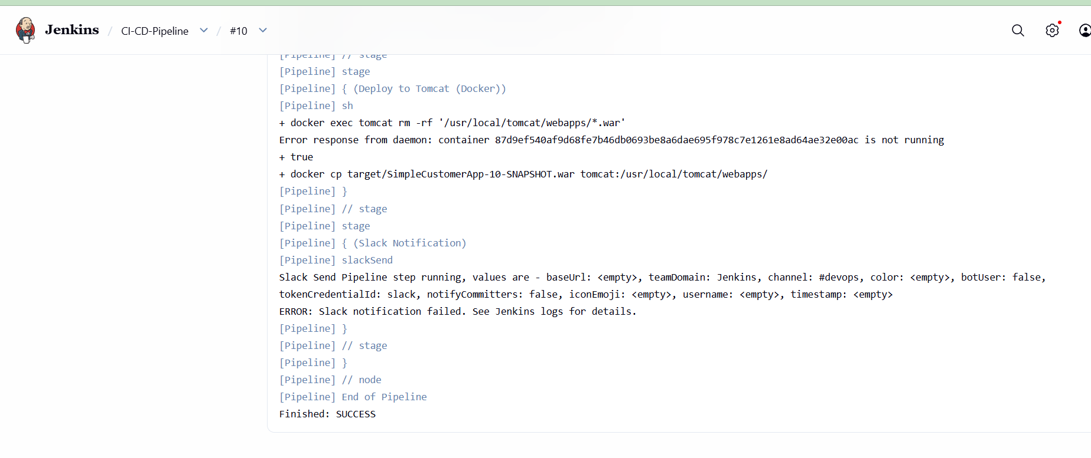

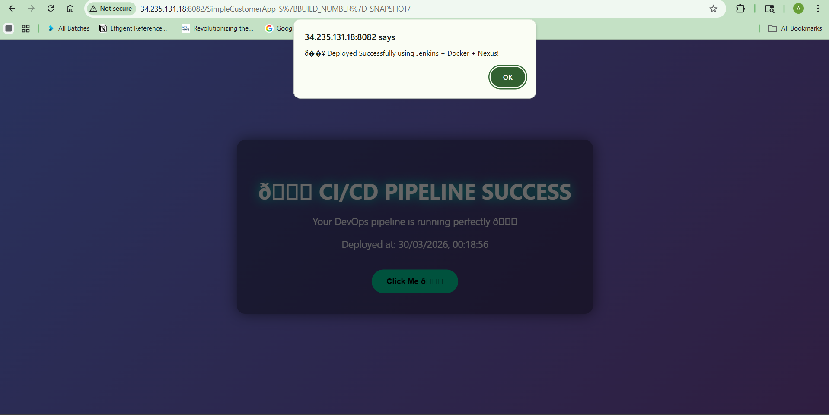
FINAL RESULT
✔ Git Clone → ✅
✔ Sonar → ✅
✔ Maven Build → ✅
✔ Nexus Upload → ✅
✔ Tomcat Deploy → ✅
✔ App Live → ✅

4) Write sample skeleton of pipelines.
Scripted Pipeline Skeleton (Jenkins)
node {
stage('Git Clone') {
echo "Cloning code from GitHub..."
}
stage('SonarQube Analysis') {
echo "Running code quality check..."
}
stage('Maven Build') {
echo "Building application..."
}
stage('Nexus Upload') {
echo "Uploading artifact to Nexus..."
}
stage('Deploy to Tomcat') {
echo "Deploying application..."
}
stage('Slack Notification') {
echo "Sending notification..."
}
}

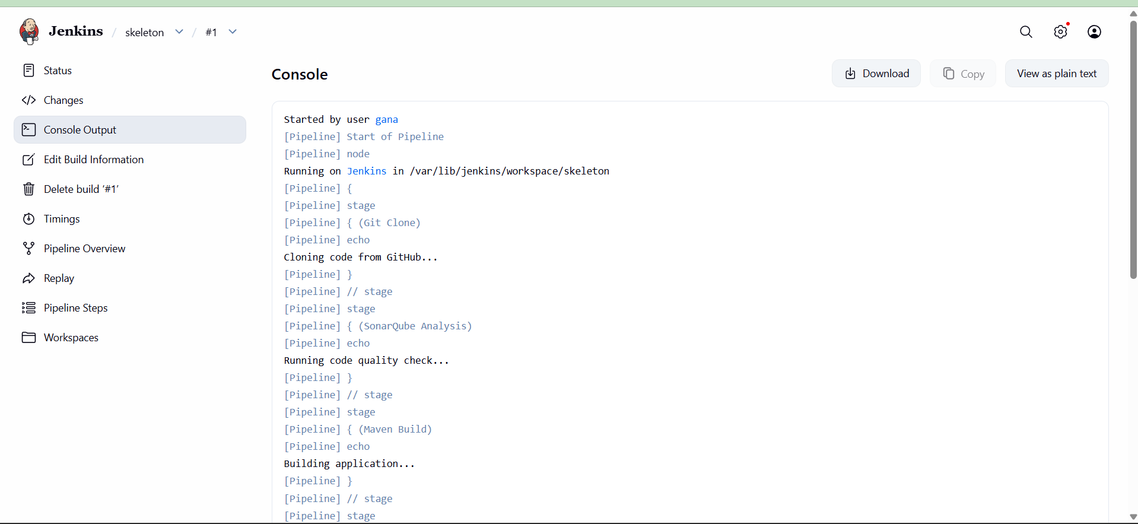

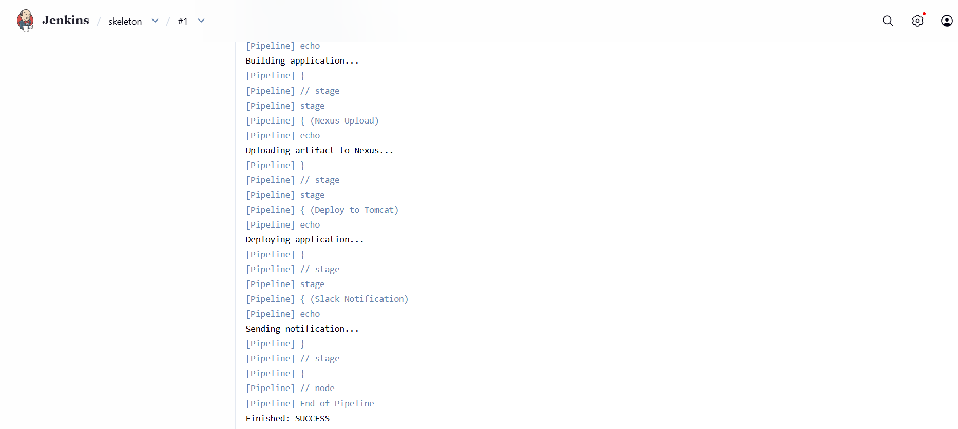

5) Create a parameterized job in Jenkins.

STEP 1: Launch EC2 (Amazon Linux)
- Go to AWS → EC2 → Launch Instance
- Select:
  - AMI: Amazon Linux 2
  - Instance Type: t2.micro (free tier)
- Security Group:
  - SSH → 22 (your IP)
  - HTTP → 80 (optional)
  - Custom TCP → 8080 (Jenkins) → Anywhere
- Launch and connect:
ssh -i your-key.pem ec2-user@your-public-ip

STEP 2: Install Java (Jenkins requirement)
sudo yum update -y
sudo yum install java-17-amazon-corretto -y
Check:
java -version

STEP 3: Install Jenkins
sudo wget -O /etc/yum.repos.d/jenkins.repo \
https://pkg.jenkins.io/redhat-stable/jenkins.repo
sudo rpm --import https://pkg.jenkins.io/redhat-stable/jenkins.io-2023.key
sudo yum install jenkins -y

STEP 4: Start Jenkins
sudo systemctl enable jenkins
sudo systemctl start jenkins
Check status:
sudo systemctl status jenkins

STEP 5: Get Jenkins Admin Password
sudo cat /var/lib/jenkins/secrets/initialAdminPassword
Copy this password

STEP 6: Open Jenkins UI
In browser:
http://<EC2-PUBLIC-IP>:8080
- Paste password
- Click Install Suggested Plugins
- Create admin user

STEP 7: Install Required Tools
Install Git
sudo yum install git -y
Install Maven
sudo yum install maven -y
Check:
mvn -version

STEP 8: Configure Tools in Jenkins
Go to:
Manage Jenkins → Global Tool Configuration
Add:
- JDK → Name: java17
- Maven → Name: maven3
Save

STEP 9: Create Parameterized Job
- Jenkins Dashboard → New Item
- Name: Parameterized-Build
- Select: Freestyle Project
- Click OK

STEP 10: Enable Parameters
✔️ Tick This project is parameterized
Add parameters:
🔹 String Parameter
- Name: BRANCH
- Default: main
🔹 Choice Parameter
- Name: ENV
- Choices:
dev
test
prod
🔹 String Parameter
- Name: MESSAGE
- Default: Hello Jenkins

STEP 11: Configure Git Repository
In Source Code Management → Git
Repository:
https://github.com/betawins/spring3-mvc-maven-xml-hello-world-1.git
Branch:
${BRANCH}

STEP 12: Add Build Logic Using Parameters
Add Execute Shell step:
echo "===== FIXING JAVA VERSION ====="
sed -i 's/<jdk.version>1.6<\/jdk.version>/<jdk.version>1.8<\/jdk.version>/g' pom.xml
echo "===== ADDING NEW WAR PLUGIN ====="
# Remove old war plugin
sed -i '/maven-war-plugin/,/<\/plugin>/d' pom.xml
# Add new war plugin
sed -i '/<\/plugins>/i \
<plugin>\
<groupId>org.apache.maven.plugins</groupId>\
<artifactId>maven-war-plugin</artifactId>\
<version>3.3.2</version>\
</plugin>' pom.xml
echo "===== VERIFY ====="
grep -i war-plugin pom.xml

STEP 13: Build Step (Maven)
In Build → Add build step → Invoke top-level Maven targets
Goals:
clean package

STEP 14: Save Job
Click Save

STEP 15: Build with Parameters
- Click Build with Parameters
- Enter:
  - BRANCH = main
  - ENV = dev/test/prod
  - MESSAGE = anything
- Click Build

STEP 16: Verify Output
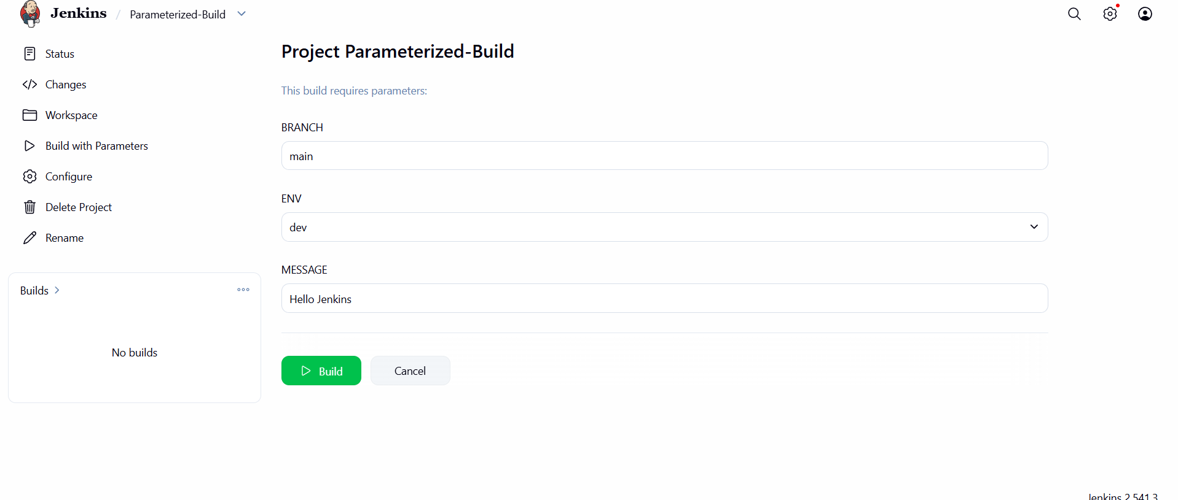Go to:
Build → Console Output
You should see:
Selected Environment: dev
Custom Message: Hello Jenkins
Deploying to DEV environment...

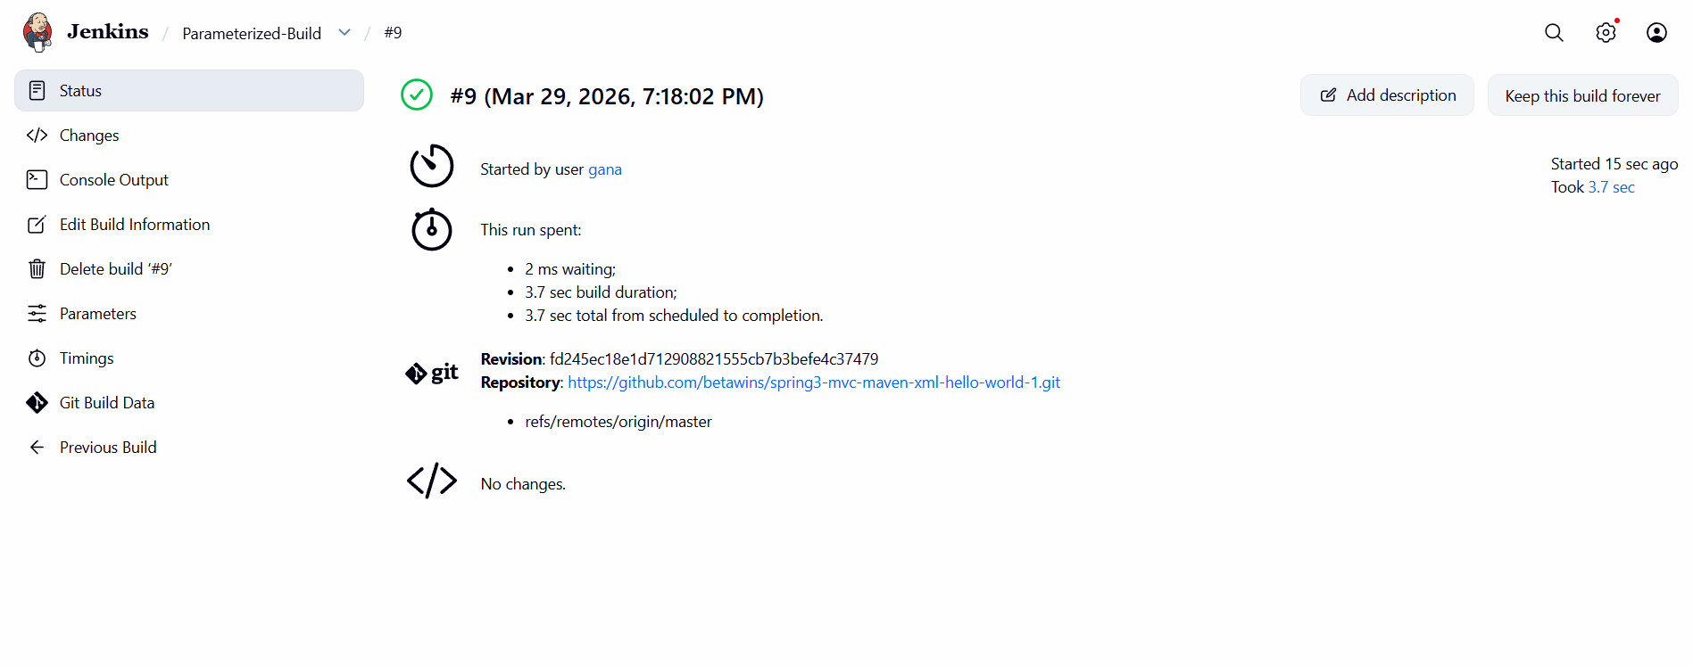
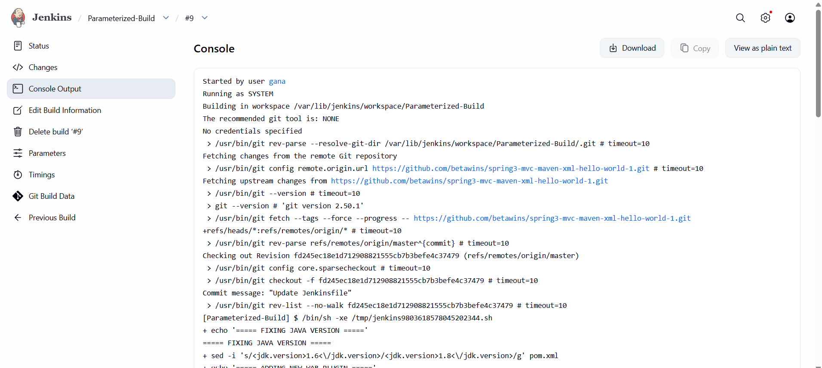
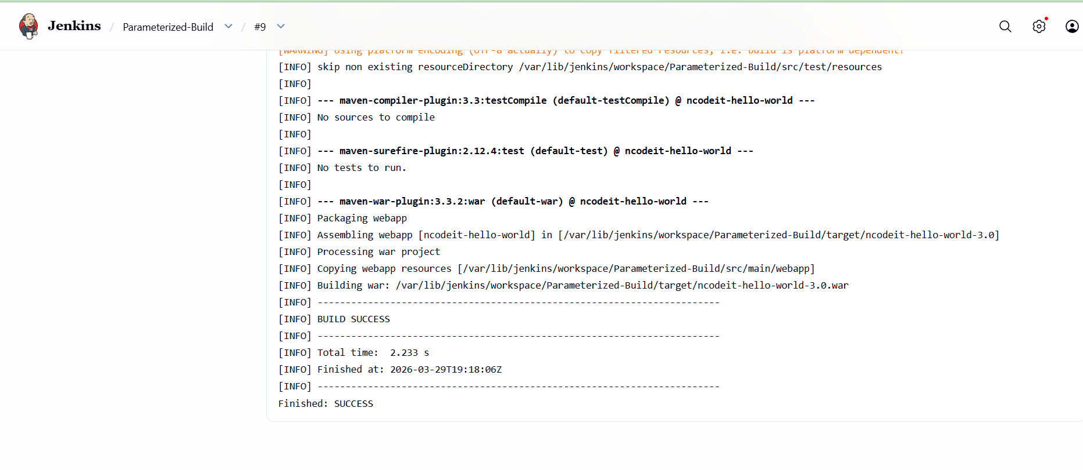

BONUS (Real DevOps Level Upgrade)
Add deployment simulation:
echo "Packaging application..."
ls -lrt target/
echo "Deploying to $ENV server..."
sleep 3
echo "Deployment successful!"

WHAT YOU LEARNED
✔️ Jenkins setup on Amazon Linux
✔️ Git + Maven integration
✔️ Parameterized builds
✔️ Dynamic branching
✔️ Environment-based deployment logic

6) Setup one slave machine for Jenkins.

We’ll do this in 4 phases:
- Launch EC2 instances
- Install Java & setup SSH
- Configure Jenkins Master
- Connect Slave (Agent)
PHASE 1: Launch EC2 Instances
Create 2 EC2 instances:
- Master (Jenkins installed)
- Slave (Agent machine)
🔹 Configuration:
- OS: Amazon Linux 2
- Instance type: t2.micro (free tier)
- Security group:
  - Port 22 (SSH) → Your IP
  - Port 8080 (Jenkins) → Anywhere (0.0.0.0/0)

PHASE 2: Install Java on BOTH machines
SSH into both instances
ssh -i your-key.pem ec2-user@<public-ip>
Install Java (Jenkins requires Java)
sudo yum update -y
sudo amazon-linux-extras enable corretto8
sudo yum install java-1.8.0-amazon-corretto -y
Verify:
java -version

PHASE 3: Setup SSH between Master → Slave
This is VERY IMPORTANT (most people make mistakes here)

Step 1: Copy public key content
cat ~/.ssh/id_rsa.pub
Copy the full output.

Step 2: Login to Slave EC2
ssh -i your-key.pem ec2-user@44.220.164.227

Step 3: Add key manually
mkdir -p ~/.ssh
nano ~/.ssh/authorized_keys
Paste the copied key.
Save:
CTRL + X → Y → Enter

Step 4: Set permissions
chmod 700 ~/.ssh
chmod 600 ~/.ssh/authorized_keys

🔹 Step 5: Test SSH (IMPORTANT)
From Master EC2:
ssh ec2-user@44.220.164.227
If it logs in WITHOUT asking password → ✅ SUCCESS
Should connect without password

PHASE 4: Install Jenkins on Master
sudo yum install git -y
sudo wget -O /etc/yum.repos.d/jenkins.repo \
https://pkg.jenkins.io/redhat-stable/jenkins.repo
sudo rpm --import https://pkg.jenkins.io/redhat-stable/jenkins.io.key
sudo yum install jenkins -y
Start Jenkins
sudo systemctl start jenkins
sudo systemctl enable jenkins
Open Jenkins UI:
http://<master-public-ip>:8080
Get initial password:
sudo cat /var/lib/jenkins/secrets/initialAdminPassword

PHASE 5: Add Slave (Agent) in Jenkins

Step 1: Go to Jenkins Dashboard
Manage Jenkins → Manage Nodes → New Node

Step 2: Configure Node
Fill details:
- Name: slave-node
- Type: Permanent Agent

Step 3: Configure settings
Field | Value
Remote root directory | /home/ec2-user
Labels | linux
Usage | Use this node as much as possible
Launch method | Launch agents via SSH

Step 4: Add Credentials
Click Add → Jenkins
- Kind: SSH Username with private key
- Username: ec2-user
- Private Key:
Paste content of:
cat ~/.ssh/id_rsa

Step 5: Add Host
- Host: Private IP of Slave
- Credentials: Select created one

Step 6: Save
Jenkins will connect automatically

FINAL VERIFICATION
Go to:
Manage Nodes → slave-node
✔ Status should be:
Connected
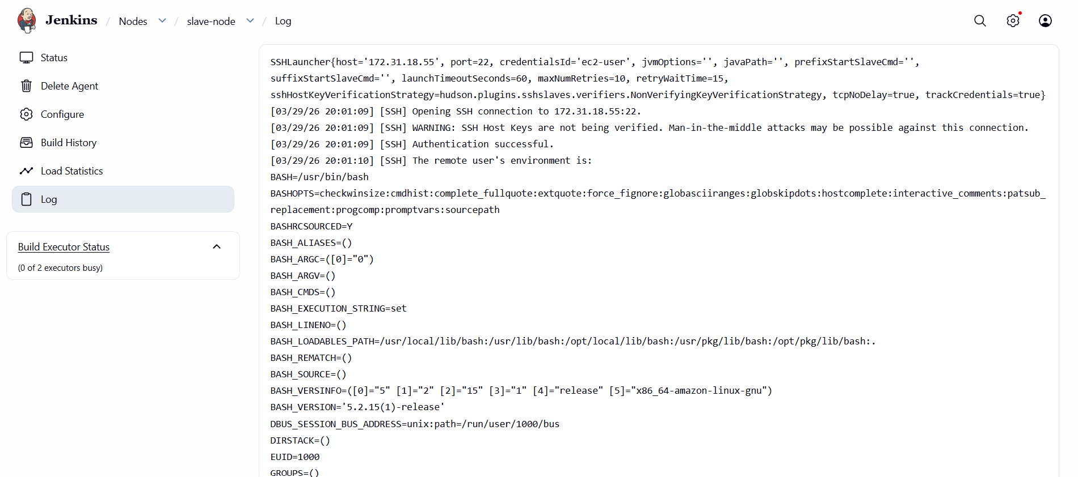
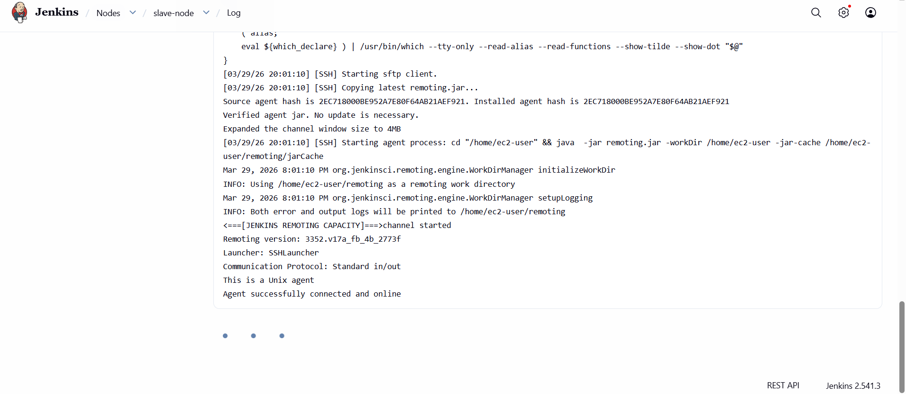

TEST JOB
Create a job:
echo "Hello from Slave"
hostname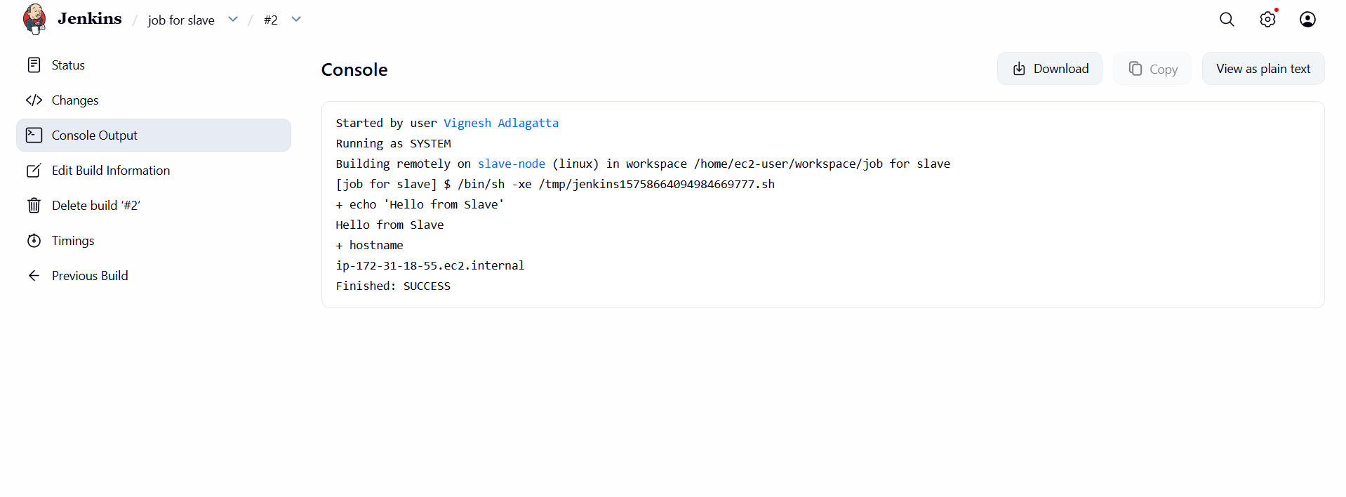
YOU JUST COMPLETED
✔ Jenkins Master → Slave connection
✔ SSH authentication
✔ Agent setup

In job config:
- Restrict where project runs → linux

COMMON ERRORS + FIX
❌ Connection refused
✔ Check Security Group → Port 22 open

❌ Permission denied (publickey)
✔ Recheck SSH key copy

❌ Java not found
✔ Install Java on slave

❌ Wrong IP
✔ Use Private IP (VERY IMPORTANT)

